INTRODUCTION OF PROJECT 3

PLATFORM AND LANGUAGE 4

HARDWARE SPECIFICATION 5

OVERVIEW OF PROJECT 6

ANALYSIS OF PROJECT 7

SYSTEM ANALYSIS 8

SYSTEM DEVELOPMENT LIFE CYCLE 10

PRESENT SETUP 11

PROPOSED SYSTEM 12

FEASIBILITY STUDY 13

BEHAVIOURAL FEASIBILITY 14

SYSTEM DESIGN 15

CONTEXT DIAGRAM 16

E-R DIAGRAM 17

DATA FLOW DIAGRAM 19

SYSTEM TESTING AND IMPLEMENTATION 21
TABLE STRUCTURE 27

LOGIN SYSTEM 33

MENU SYSTEM 35

PROGRAM INPUT 36

PROGRAM OUTPUT 40

PROGRAM CODE 46

PIE CHART 104

BIBLIOGRAPHY 105

Introduction

The objective of “Hotel Management System” is to assist and speed up the process of Hotel Management. Hotel Management not only maintains the database for future reference, but also plays an important role in making a paperless office.
Many steps are involved in between accepting Employee and Customer enquiry and supplying the requested information to the Hotel Management and processes in average with manual processing time of fifteen minutes to half an hour.
Fee-Info reduces most of the typing works involved specially in preparing entry of student records and fee records in the college.
It improves the searching facility and easily updates the record. It also gives a detail report on student information and other fees in the college which can improve the processing plan.

Platform & Language Used

Platform :- WINDOWS 98, WINDOWS XP.

Language :- Visual Basic(Front-End)
MS-ACCESS(Back-End)

MINIMUM HARDWARE SPECIFICATION

PROCESSOR : PENTIUM-I

RAM : 16MB

HARD DISK : 1.2GB

MONITOR : COLOURED MONITOR(SAMSUNG/LG)

MOUSE : SCROLLABLE MOUSE

KEYBOARD : COMPATIBLE KEYBOARD(102/103
KEYS)

OPERATING SYSTEM : WINDOWS-95

Overview Of The Project

The superintendent scrutinizes the requirement and prepares work quotations based on enquiry, which contains detail of student data like code no, name, fee of study, address, name of course and session etc.
This software provides the feature to maintain the records of student of the college like Total number of Student in class, Total Fee detail, Student’s Due fees and Enquiry etc.
The superintendent after the receipt of the information of student and Enquiry makes the required report like Late-fine sheet of student, admission sheet of enquiry student, list of student admitted in any course, address sheet of student which is admitted in Arcade Business College.
It maintains the final information of student like total fee calculation, fee payment, fee dues etc.
It also maintains the final information of student like total student, total fee detail, student’s address, dues fee calculation with due date etc.

Analysis of the Fee Information System: -

- System Analysis – An introduction

- Present System

- Problem With Present System

- Purpose Of The Proposed System

- Benefits Of The Proposed System

- Feasibility Study –

  - Technical Feasibility

  - Behavioral Feasibility

  - Economical Feasibility

- Requirements Of The Proposed System

SYSTEM ANALYSIS – AN INTRODUCTON

System Analysis and Design refers to the process of examining a business situation with the intent of improving it through better methods and procedures.

System Analysis is the process of gathering and interpreting the facts, diagnosing the problems and using the information tool to recommends the improvements of the system. System designing is the process of planning a new business system or to replace or compliment the existing system.
The system Development Life Cycle (SDLC) method is classically thought of as the set of activities that analyzers, Designers or Users carry out to develop and implements the information system.
The nine Phases that make up the System Development
Life Cycle is: -

- REQUIREMENT SPECIFICATION

- REQUIREMENT DETERMINATION

- FEASIBILITY STUDY

- SYSTEM ANALYSIS

- HARDWARE STUDY

- SYSTEM DESIGN

- TESTING AND IMPLEMENTATION

- EVALUATION

- MAINTAINCE AND MODIFICATION

SYSTEM DEVELOPMENT LIFE CYCLE DIAGRAM

Logical
System
Design
System Implementation
User
Feasibility Study
System
Revised
Requirement
Configuration
Test
Plan
Functional Specification
System Design
Decision to Design
Hotel Management
Requirement Determination
Requirement Specification
Revised prioritized Requirement Specification
Feasibility Analysis
System Specification
H/W
Study
System Evaluation
System Modification And Maintenance
Improve System
Physical
Requirement

PRESENT SETUP
Before any big and complex project such as the proposed System is taken up, it is Vital to study the existing system in detail.

Present Setup:
The objective of Fee Info is to assist and speed up the process of College information Processing in a firm of any size.
PROBLEM WITH PRESENT SETUP:
- The present system is very typical.
- It takes more-and-more time to do processing of this type of job.
- It takes more man power to prepare the student enquiry register, maintain student record, late fee detail & every student’s fee detail records.
- It can maintain more than one file particularly.
- Integrity of data cannot be maintained.
- Redundancy is obstructing to maintain the data.
- If we have to find out a particular record, present system take more time.
- Modification in records is very difficult job.
So present system has many unavoidable problems.

PURPOSE OF THE PROPOSED SYSTEM:

The main purpose of the proposed system is to reduce the cost of man power and make system paperless. It takes less time to do their job. It is a user-friendly system ,any body can do this job who has learned computer operation. It does the job faster than the present system.

BENEFITS OF PROPOSED SYSTEM:

- Reduce the cost.
- Updating is easier.
- Job is faster.
- Easy to handle.
- Integrity can be maintained.
- Searching is so easy.
- Reports are easily generated and more attractive.
- We can generate and see any report in our own way.

FEASIBILITY STUDY

Introduction:
Before developing any computerized system it is imperative to examine the existing system to find out the drawbacks and requirements, which will be satisfied by the proposed system. It is necessary to examine the current procedure and information flow, to locate problem in the existing system, to identify what resources are used, to discuss with higher authorities the improvements that are necessary.
Feasibility Study:
Feasibility study is the procedure to identify, describe and evaluate proposed system and select the vast possible action for the job in terms of Economic, Technical and behavioral constraints.
Cost benefit Analysis:
The cost benefit analysis is to be considered as per given headings:

Technical Feasibility
Token Ring in the entire company makes the proposed system technically feasible to implement. The web server of the department can cater the request of any client through the Token Ring Network System thus fulfilling the basic requirement of the proposed system that is to compute data online from various processes.

Behavioural Feasibility
Regarding the behavioral feasibility, care had to be taken to provide a user- friendly system. It includes the training of the user on the proposed system. Care has been taken to provide the user as much facility as possible. The screen design is very much user friendly. Data entry jobs have been kept very easy and user friendly so that users can be trained very easily.

Requirement of the Proposed System

Requirement determination techniques involve studying the current system to find out how it works and identifying the area, which require changes. It may include alternative way to capture or process data.
After the initial study of the various activities, it was determined that the whole proposed system would consist of following modules:

System Design – An Introduction

System design is a solution for”How to approach the creation of a new system”. It provides the understanding and procedural details necessary for implementing the system recommended in the feasibility study. Emphasis is on translating the performance requirements into design specifications. Design goes through logical and Physical stages of development.
The design covers the following: -
- Review of the current physical system – its data-flow, file content volume, frequencies etc.
- Preparation of output specifications- determination of format, content and frequency of reports etc.
- Preparation input specifications- determining the flow of the document from input data source to the actual input location, format and content of input functions.
- Preparations of edit, security and control specifications.
- Specification of plan to be implemented.

CONTEXT DIAGRAM

Context diagram represents the whole system as a single process.
It identifies the major input to the system and also identifies where the output of the system goes.

DEMAND ORDER
DELIVERY NOTE
ENQUIRY
QUOTATION
Hotel Managemet
System
Customer
PERMANENT
RECORDS

E-R DIAGRAM

Entity – Relationship diagram for a pale ontological species occurrence data model.
The E-R (Entity – Relationship) data model views the real world as a set of basic objects (entities and relationships) among these objects.
It is intended primarily for the DB design process by allowing the specification of an enterprise scheme. This represents the overall logical structure of the DB.
In Fee-Info processing system has following entities:
- STUDENT
- COURSE
- FEE STRUCTURE

E-R DIAGRAM
STUDENT
Student ID
Name
Address
Phone
COLLEGE
University
Course
Roll No.
Date of Admission
Admission
FEE DETAIL
Fee Code
Name
Roll
Reg. No.
Gives Information

DATA FLOW DIAGRAM

Data flow diagram or DFD provides an easy, graphical means of modeling the flow of data through a system whether a manual, automated or mixture of both. It is a picture of the flow of the data through a system of any kind, showing the external entities that are sources or destinations of data, the processes that transform data and the places where data are stored.

Course_Master
STUDENT
FEE INFORMATION
AND
PROCESSING SYSTEM

DUES BILL MASTER
FEE MASTER
COURSE
ENQUIRY
Student_Master
DUES REPORT
Fee_Master

LEVEL 0 (ZERO) DFD:

Hotel Management System
CUSTOMER
MASTER RECORDS
SERVICES

SYSTEM TESTING AND IMPLEMENTATION

INTRODUCTION:
As a step in system development life cycle, testing and implementation consist of final steps that put the new system into operation. An exhaustive test must be conducted to ascertain that the system produces right result. This chapter throws light on testing and implementation of the system.

Testing:

Testing involves executing the program (or part of it) using sample data and inferring from the output whether the software performs correctly or not. This can be done during module development (until testing 0 or when several modules are combined).

Defect Testing:

Defect Testing is testing for situation where the program does not meet its functional specification. Performance testing tests a system’s performance or reliability under realistic loads. This may go some way to ensuring that the program meets its nonfunctional requirements.

Debugging:

Debugging is a cycle of detection, location, repair and test. Debugging is a hypothesis testing process. When a bug is detected, the tester must form a hypothesis about the cause and location of the bug. Further execution of the program will usually take place to confirm the hypothesis. If the hypothesis is demonstrated to be incorrect, a new hypothesis must be formed. Debugging tools that show the state of the program are useful for this. But inserting print statement is often the only approach. Experienced debuggers use their knowledge of common and/or obscure bugs to facilitate the hypothesis testing process. After fixing a bug, the system must be retested to ensure that the key has worked and that no other bugs have been introduced. This is called regression testing. In principle, all tests should be performed again but this is often too expensive to do.

Testing Planning:

Testing needs to be planned to be cost and time effective. Planning is setting out standards for tests. Test plans out the context on which individual engineers can place their own work.

Typical Test Plan contains:

- Overview of testing process.
- Requirement tractability.
- List of items to be tested.
- Schedule.
- Recording procedure so that test results can be audited
- Hardware and Software requirements.

Overview of Testing Strategies:

Alpha Testing And Beta Testing:

The customer conducts the Alpha Test at the Developer’s site. The software is used in a natural setting with the developer” Looking over the shoulder” of the user and recording errors and usage problems. Alpha Tests is also known as Acceptance test since it is performed before the system is accepted as being fit for the intended users.

The Beta test is conducted at one more customer site by the end user of the software. Unlike Alpha testing, the developer is not present. Therefore, the beta test is ‘live’ application of the software in an environment that cannot be controlled by the developer. The customer records all problems (real or imaging) that are encountered during beta testing and reports these to the developer at regular intervals. System or different stages of the process.

Top down testing:

This approach tests high levels of system detailed components. This is appreciated when developing the systems top-down. Likely to show structural design errors early, validation (as distinct from verification) can begin early. Its’ disadvantages is that stubs needs to be generated (extra efforts) and might be Impracticable, if component is complex. Tests output may be difficult to observe.

Bottom-up testing:

This is opposite to top-down testing. This testing tests low-level unit that works up Hierarchy.
The advantage and disadvantage of bottom-up mirror those of top-down .In this testing there is need to write test-drive for each unit. These are reusable as the units itself. Combining top-down development with bottom-up testing means that all parts of systems must be implemented before testing can begin. Therefore it does not accord with incremental approach discussed above.

Black-Box (functional) testing:

Black Box Testing is concerned with the proper execution of the program specifications. In this testing, each function or sub-program used in the main program is first identified. Test cases are devised to test each function or sub-program separately. Test cases are decided solely on the basis of the requirements or specifications of the program and not on the basis of the coding. Black Box testing is complimentary to white box methods. This type of testing attempts to find the following errors:
- Interface errors
- Incorrect or missing functions
- Errors in external database access
- Performance errors
- Initialization and termination errors

White-Box (structural) testing:

Core advantage is that structure of code can be used to find out how many test cases need to be performed. Knowledge of the algorithm (examination of the code) can be used to identify the testing based on knowledge of structure of component. Flow graphs are pictorial representation of the paths of control through program. Use flow graph to design cases that execute each path. Static tools may be used to make this easier in programs that have complex branching structure tool supports.

Interface Testing:

Usually done at integration stage when modules or sub-systems are combined. Objective is to detect errors or invalid assumptions about interfaces between modules. Reason these are not shown up to testing is that test case may perpetuate same incorrect assumption made by modular designer. Particularly important when OO development has been used.

Stress testing:

Test system’s ability to cope with a specified load (e.g. transactions per second). Test plans to increase load incrementally to go beyond design limit until system fails (this test particularly important for distributed systems).

Back–to-back-testing:

Comparison of test results from different versions of the system (e.g. compare with prototype, previous version or different configuration). Process runs first system, saving test case results. Run second time also saving its results. Compare results files. Note that no bugs imply any bugs.

Following testing has been done in eg. Learning management system:

Installation test:

The accepted system was installed in the environment in which it would be used and final installation test was performed to make sure that the system is working, as it should.

User acceptance test:

This task has been carried out in the implementation and testing of the application for various entities defined in the Hotel Management system. The various entities would be as under:

  - Customer,
  - Services,
  - Employee,
  - Bill Details,
  - MainBill,
  - Report

TABLE STRUCTURE

Table Name : Course_Master

Data Name | Type | Size
CourseCode | Text | 3
CourseType | Text | 20
University | Text | 40
Course | Text | 20
CourseName | Text | 40
SpecifiedCode | Text | 2

Table Name : Paper_Master

Data Name | Type | Size
PaperCode | Text | 3
Name | Text | 40
Comment | Text | 50

Table Name : University_Master

Data Name | Type | Size
Uni_Code | Text | 5
Uni_Name | Text | 50
Table Name : Enquiry_Master

Data Name | Type | Size
EnquiryCode | Text | 8
FormNo | Text | 10
Name | Text | 40
FatherName | Text | 50
Address | Text | 150
City | Text | 50
Pin | Text | 7
State | Text | 30
TelNo | Text | 13
Year1 | Text | 5
EnquiryDate | Date/Time | 8
PassExam | Text | 20
PassYear | Text | 5
MarksPer | Text | 7
Addver | Text | 50
University1 | Text | 40
Course | Text | 20
Employment | Text | 15
PlacedAt | Text | 20
OtherSource | Text | 20
AdmitStatus | Text | 6
EnqAttend | Text | 50

Table Name : Fee_Master

Data Name | Type | Size
Code | Text | 10
Course | Text | 20
Session1 | Text | 10
Semester | Text | 5
FeeAmount | Text | 5

Table Name : FeeCollection_Master

Data Name | Type | Size
Roll | Text | 15
RegNo | Text | 15
Course | Text | 10
Session1 | Text | 10
DDate | Text | 15
ReceiptNo | Text | 10
Amount | Double | 8
FeeCode | Text | 15
Description | Text | 40
Mode | Text | 10
Bank | Text | 50
Branch | Text | 50
IDate | Text | 15
DDNo | Text | 20
Table Name : FeeDetail_Master

Data Name | Type | Size
Course | Text | 10
Session1 | Text | 10
FeeDetail_Code | Text | 10
Amount | Text | 6
Description | Text | 40

Table Name : LateCalTemp

Data Name | Type | Size
Course | Text | 10
Session1 | Text | 15
Description | Text | 40
Roll | Text | 15
RegNo | Text | 15
Name | Text | 40
Amount | Text | 10
DueDate | Date/Time | 8
LateFine | Text | 10
Total | Text | 10
Fine | Double | 8

Table Name : LateFee_Master

Data Name | Type | Size
FeeCode | Text | 15
Due_Date | Date/Time | 8
LateAmount | Double | 8
Day1 | Integer | 2
Table Name : Student_Master

Data Name | Type | Size
StudentID | Text | 10
Name | Text | 40
FName | Text | 50
CAddress | Text | 150
CCity | Text | 30
CPin | Text | 6
CState | Text | 30
CTel | Text | 15
PAddress | Text | 150
PCity | Text | 30
PPin | Text | 6
PState | Text | 30
PTel | Text | 15
Course | Text | 10
Session1 | Text | 10
Roll | Text | 15
RegNo | Text | 15
AdmissionDate | Text | 15
ScholarShip | Text | 5
DateOfBirth | Text | 15
University | Text | 40

USER LOGIN FRAME

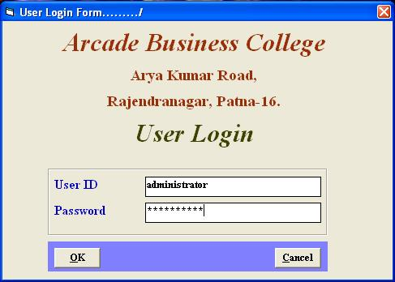

MENU SYSTEM



Program Input

ENQUIRY DETAIL

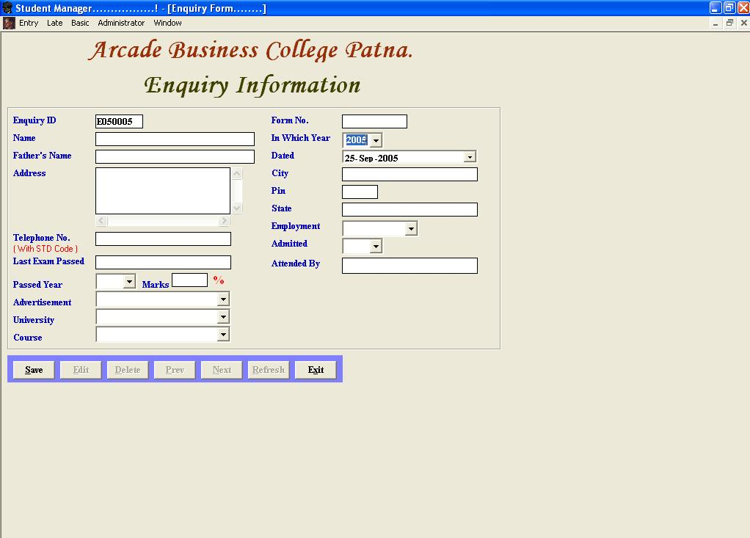

STUDENT INPUT FRAME

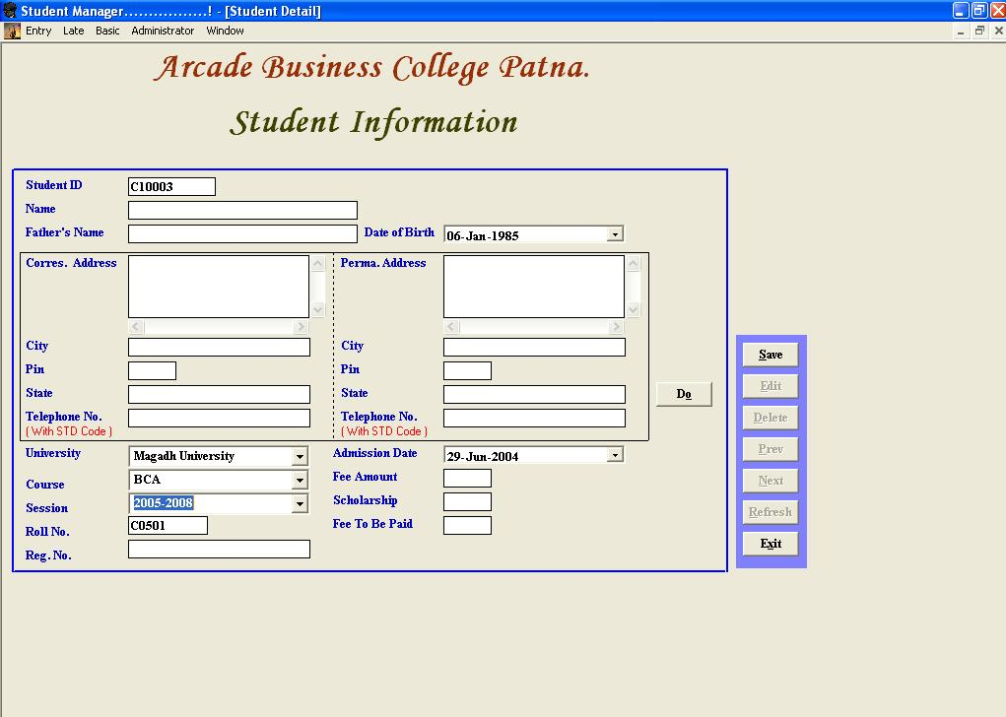

DETAIL COLLECTION OF FEE

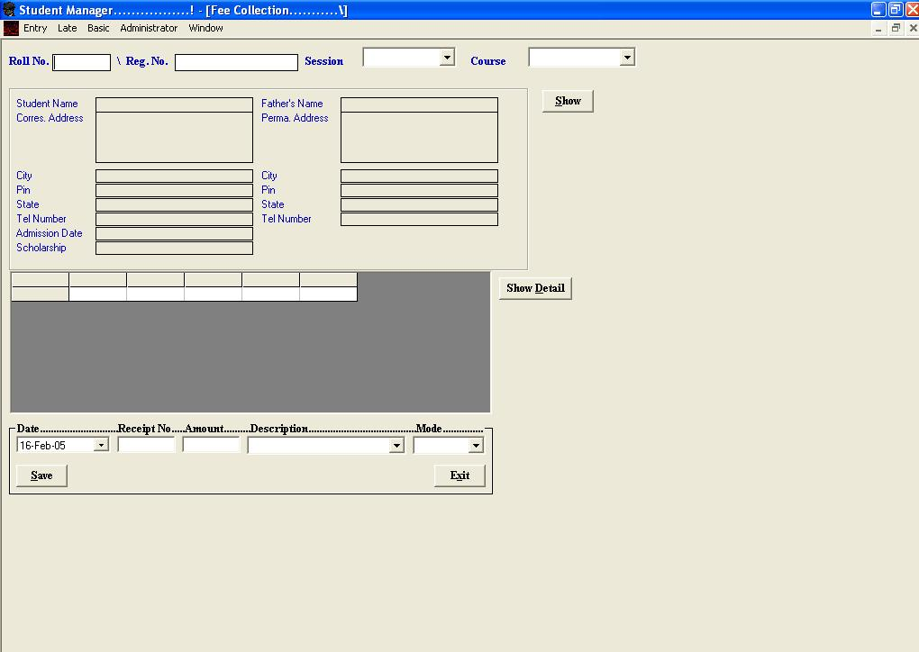

ENQUIRY OUTPUT

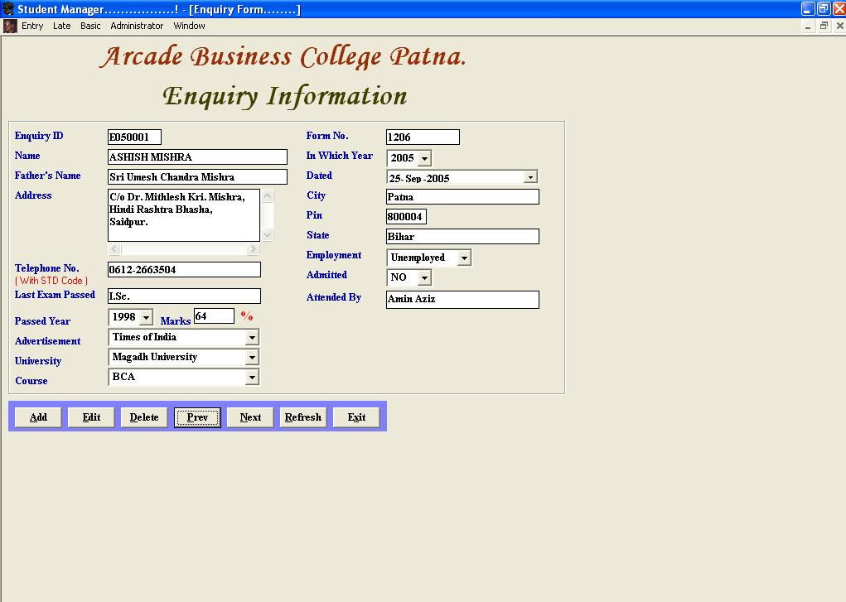

OUTPUT OF STUDENT DETAIL

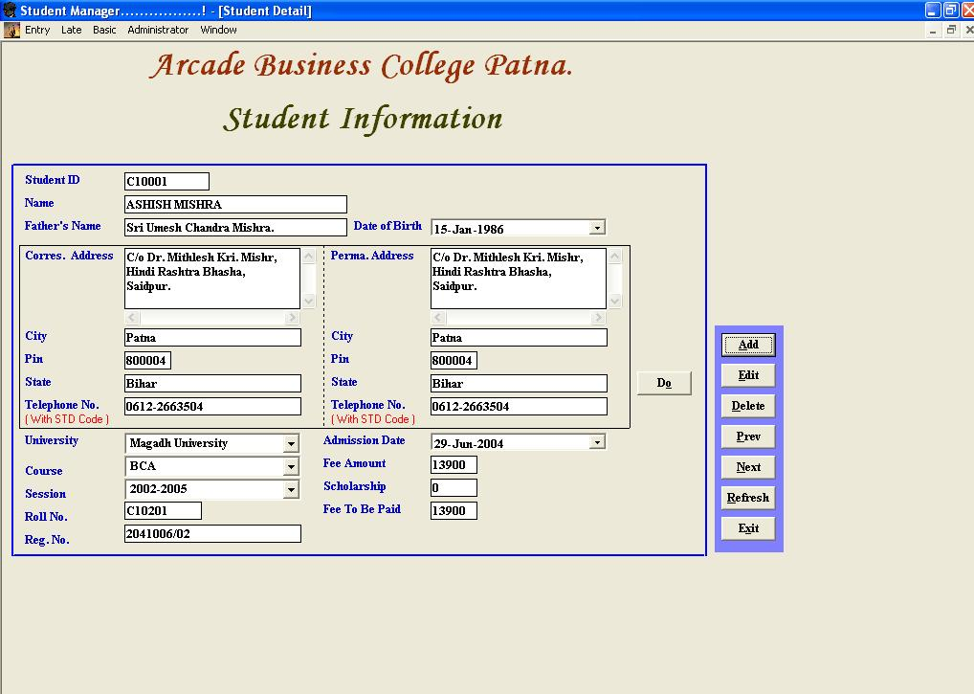

OUTPUT OF FEE COLLECTION

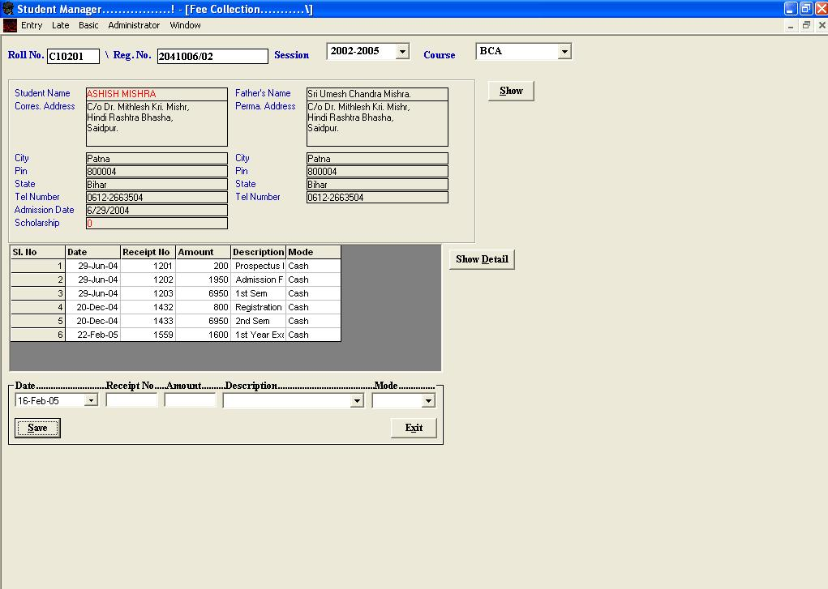

FEE REPORT

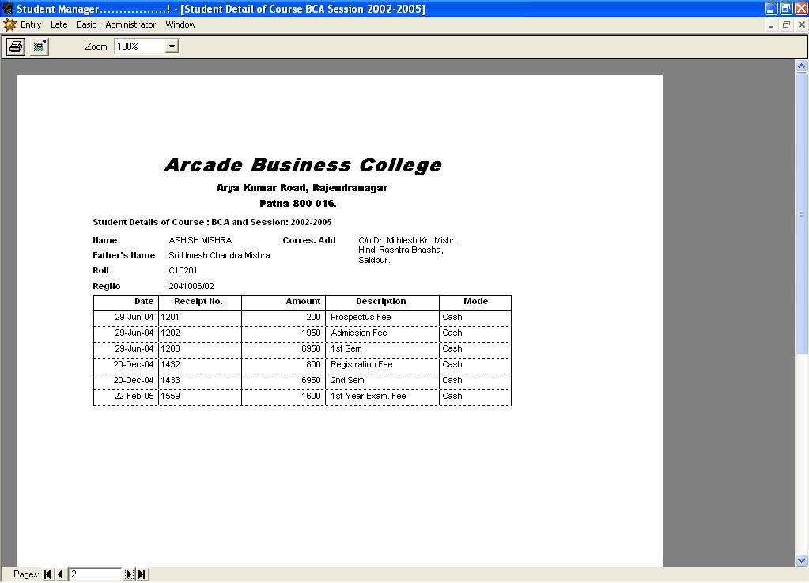

STUDENT REPORT

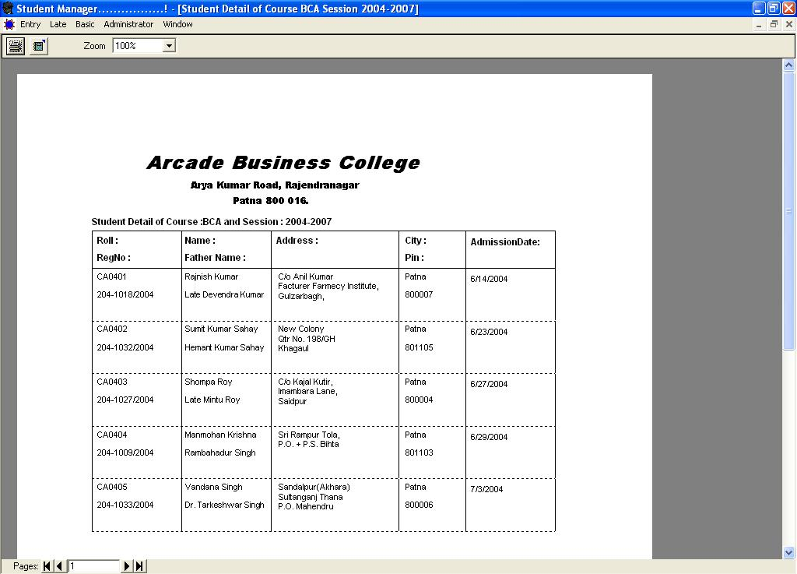

Frame : FeeMDIForm

Private Sub MDIForm_Load()
On Error Resume Next
Me.WindowState = 2
Con.ConnectionString = "Provider=Microsoft.Jet.OLEDB.4.0;Data Source=C:\Program Files\Fee's Software\Data Base\Student_Master.mdb;Persist Security Info=False"
Con.Open
End Sub
Private Sub MnuAdminisChange_Click()
On Error Resume Next
Admin_Master.Show
End Sub
Private Sub MnuAdminisUser_Click()
On Error Resume Next
User_Master.Show
End Sub
Private Sub MnuBasicCourse_Click()
On Error Resume Next
Course_Master.Show
End Sub
Private Sub MnuBasicFee_Click()
On Error Resume Next
Fee_Master.Show
End Sub
Private Sub MnuBasicFeeDetail_Click()
On Error Resume Next
Tot_Fee.Show
End Sub
Private Sub MnuBasicNewspaper_Click()
On Error Resume Next
Paper_Master.Show
End Sub
Private Sub MnuBasicUni_Click()
On Error Resume Next
University_Master.Show
End Sub
Private Sub MnuEntryAddStudent_Click()
On Error Resume Next
Student_Master.Show
End Sub
Private Sub MnuEntryEnquiry_Click()
On Error Resume Next
Enquiry_Master.Show
End Sub
Private Sub MnuEntryExit_Click()
On Error Resume Next
End
End Sub
Private Sub MnuEntryFeeCollection_Click()
On Error Resume Next
FeeCollection.Show
End Sub
Private Sub MnuLateCal_Click()
On Error Resume Next
Late_Calculation.Show
End Sub
Private Sub MnuLateDetail_Click()
On Error Resume Next
Late_Fee.Show
End Sub
Private Sub MnuLateQuery_Click()
On Error Resume Next
QueryAnalizer.Show
End Sub
Private Sub MnuWindowAbout_Click()
frmAbout.Show
End Sub
Private Sub MnuWindowCascade_Click()
Me.Arrange vbCascade
End Sub
Private Sub MnuWindowHorizontal_Click()
Me.Arrange vbTileHorizontal
End Sub
Private Sub MnuWindowVertical_Click()
Me.Arrange vbTileVertical
End Sub

Frame : University_Master

Dim RS As New ADODB.Recordset
Private Sub CmdAdd_Click()
On Error Resume Next
Dim RsTemp As New ADODB.Recordset
Dim Sql As String
If CmdAdd.Caption = "&Add" Then
ClearAll
Frame1.Enabled = True
CmdAdd.Caption = "&Save"
GenerateCode
TxtName.SetFocus
CmdEdit.Enabled = False
CmdDelete.Enabled = False
CmdPrev.Enabled = False
CmdNext.Enabled = False
CmdRefresh.Enabled = False
Else
If MsgBox("Do you want to Save ?", vbYesNo) = vbYes Then
If Check() = True Then
Sql = "Insert Into University_Master Values('" & TxtCode.Text & "','" & TxtName.Text & "')"
Set RsTemp = Con.Execute(Sql)
Frame1.Enabled = False
CmdAdd.Caption = "&Add"
CmdEdit.Enabled = True
CmdDelete.Enabled = True
CmdPrev.Enabled = True
CmdNext.Enabled = True
CmdRefresh.Enabled = True
Display
End If
Else
Frame1.Enabled = False
CmdAdd.Caption = "&Add"
CmdEdit.Enabled = True
CmdDelete.Enabled = True
CmdPrev.Enabled = True
CmdNext.Enabled = True
CmdRefresh.Enabled = True
Display
End If
End If
Set RsTemp = Nothing
End Sub
Private Sub CmdDelete_Click()
On Error Resume Next
Dim RsTemp As New ADODB.Recordset
Dim Sql As String
If MsgBox("Do you want to Delete ?", vbYesNo) = vbYes Then
Sql = "Delete from University_Master where Uni_Code='" & TxtCode.Text & "'"
Set RsTemp = Con.Execute(Sql)
RS.Close
Form_Load
Else
Display
End If
End Sub
Private Sub CmdEdit_Click()
On Error Resume Next
Dim RsTemp As New ADODB.Recordset
Dim Sql As String
If CmdEdit.Caption = "&Edit" Then
Frame1.Enabled = True
CmdEdit.Caption = "&Save"
CmdAdd.Enabled = False
CmdDelete.Enabled = False
CmdPrev.Enabled = False
CmdNext.Enabled = False
CmdRefresh.Enabled = False
TxtName.SetFocus
Else
If MsgBox("Do you want to Save ?", vbYesNo) = vbYes Then
Sql = "Update University_Master set Uni_Name='" & TxtName.Text & "' where Uni_Code='" & TxtCode.Text & "'"
Set RsTemp = Con.Execute(Sql)
Frame1.Enabled = False
CmdEdit.Caption = "&Edit"
CmdAdd.Enabled = True
CmdDelete.Enabled = True
CmdPrev.Enabled = True
CmdNext.Enabled = True
CmdRefresh.Enabled = True
Display
Else
Frame1.Enabled = False
CmdEdit.Caption = "&Edit"
CmdAdd.Enabled = True
CmdDelete.Enabled = True
CmdPrev.Enabled = True
CmdNext.Enabled = True
CmdRefresh.Enabled = True
Display
End If
End If
Set RsTemp = Nothing
End Sub
Private Sub CmdExit_Click()
On Error Resume Next
RS.Close
Unload Me
End Sub
Private Sub CmdNext_Click()
On Error Resume Next
RS.MoveNext
If Not RS.EOF Then
Display
Else
MsgBox "There is no record after this one."
RS.MoveLast
End If
End Sub
Private Sub CmdPrev_Click()
On Error Resume Next
RS.MovePrevious
If Not RS.BOF Then
Display
Else
MsgBox "There is no record before this one."
RS.MoveFirst
End If
End Sub
Private Sub CmdRefresh_Click()
On Error Resume Next
RS.Close
Form_Load
End Sub
Private Sub Form_Load()
On Error Resume Next
Me.WindowState = 2
Dim Sql As String
Sql = "Select * from University_Master Order By Uni_Code"
RS.Open Sql, Con, adOpenStatic, adLockBatchOptimistic
Display
End Sub
Private Sub Display()
On Error Resume Next
TxtCode.Text = IIf(IsNull(RS("Uni_Code")), "", RS("Uni_Code"))
TxtName.Text = IIf(IsNull(RS("Uni_Name")), "", RS("Uni_Name"))
End Sub
Private Sub ClearAll()
On Error Resume Next
TxtCode.Text = ""
TxtName.Text = ""
End Sub
Private Sub GenerateCode()
On Error Resume Next
Dim RsTemp As New ADODB.Recordset
Dim Sql As String
Sql = "Select Uni_Code From University_Master Order by Uni_Code"
RsTemp.Open Sql, Con, adOpenStatic, adLockBatchOptimistic
If RsTemp.BOF Then
TxtCode.Text = "U01"
Else
RsTemp.MoveLast
TxtCode.Text = "U" + Format$(Val(Mid(RsTemp("Uni_code"), 2, 2)) + 1, "00")
End If
End Sub
Private Function Check() As Boolean
If TxtName.Text = "" Then
MsgBox "University Name cannot be left blank .....! Please enter the University Full Name.", vbExclamation
TxtName.SetFocus
Check = False
Else
Check = True
End If
End Function
Private Sub TxtCode_KeyPress(KeyAscii As Integer)
On Error Resume Next
If KeyAscii = 13 Then
TxtName.SetFocus
End If
End Sub
Private Sub TxtName_KeyPress(KeyAscii As Integer)
On Error Resume Next
If KeyAscii >= 97 And KeyAscii <= 122 Then
KeyAscii = KeyAscii - 32
End If
If KeyAscii = 13 Then
If CmdAdd.Enabled = True Then
CmdAdd.SetFocus
Else
CmdEdit.SetFocus
End If
End If
End Sub

Frame : Course_Master

Dim RS As New ADODB.Recordset
Private Sub CmdAdd_Click()
On Error Resume Next
Dim RsTemp As New ADODB.Recordset
Dim Sql As String
If CmdAdd.Caption = "&Add" Then
ClearAll
Frame1.Enabled = True
CmdAdd.Caption = "&Save"
GenerateCode
ComCourse.SetFocus
CmdEdit.Enabled = False
CmdDelete.Enabled = False
CmdPrev.Enabled = False
CmdNext.Enabled = False
CmdRefresh.Enabled = False
Label9.Visible = True
ComCode.Visible = True
TxtCourseCode.Locked = False
Load_University
Load_Code
Else
If MsgBox("Do you want to Save ?", vbYesNo) = vbYes Then
If Check() = True Then
If Code() = True Then
Sql = "Insert Into Course_Master Values('" & TxtCode.Text & "','" & ComCourse.Text & "','" & ComUniversity.Text & "','" & TxtCourse.Text & "','" & TxtName.Text & "','" & TxtCourseCode.Text & "')"
Set RsTemp = Con.Execute(Sql)
Frame1.Enabled = False
CmdAdd.Caption = "&Add"
CmdEdit.Enabled = True
CmdDelete.Enabled = True
CmdPrev.Enabled = True
CmdNext.Enabled = True
CmdRefresh.Enabled = True
Label9.Visible = False
ComCode.Visible = False
TxtCourseCode.Locked = True
Display
End If
End If
Else
Frame1.Enabled = False
CmdAdd.Caption = "&Add"
CmdEdit.Enabled = True
CmdDelete.Enabled = True
CmdPrev.Enabled = True
CmdNext.Enabled = True
CmdRefresh.Enabled = True
Label9.Visible = False
ComCode.Visible = False
TxtCourseCode.Locked = True
Display
End If
End If
Set RsTemp = Nothing
End Sub
Private Sub CmdDelete_Click()
On Error Resume Next
Dim RsTemp As New ADODB.Recordset
Dim Sql As String
If MsgBox("Do you want to Delete ?", vbYesNo) = vbYes Then
Sql = "Delete from Course_Master where CourseCode='" & TxtCode.Text & "'"
Set RsTemp = Con.Execute(Sql)
RS.Close
Form_Load
Else
Display
End If
End Sub
Private Sub CmdEdit_Click()
On Error Resume Next
Dim RsTemp As New ADODB.Recordset
Dim Sql As String
If CmdEdit.Caption = "&Edit" Then
Frame1.Enabled = True
CmdEdit.Caption = "&Save"
CmdAdd.Enabled = False
CmdDelete.Enabled = False
CmdPrev.Enabled = False
CmdNext.Enabled = False
CmdRefresh.Enabled = False
ComCourse.SetFocus
Load_University
Else
If MsgBox("Do you want to Save ?", vbYesNo) = vbYes Then
Sql = "Update Course_Master set CourseType='" & ComCourse.Text & "',University='" & ComUniversity.Text & "',Course='" & TxtCourse.Text & "',CourseName='" & TxtName.Text & "',SpecifiedCode='" & TxtCourseCode.Text & "' where CourseCode='" & TxtCode.Text & "'"
Set RsTemp = Con.Execute(Sql)
Frame1.Enabled = False
CmdEdit.Caption = "&Edit"
CmdAdd.Enabled = True
CmdDelete.Enabled = True
CmdPrev.Enabled = True
CmdNext.Enabled = True
CmdRefresh.Enabled = True
Display
Else
Frame1.Enabled = False
CmdEdit.Caption = "&Edit"
CmdAdd.Enabled = True
CmdDelete.Enabled = True
CmdPrev.Enabled = True
CmdNext.Enabled = True
CmdRefresh.Enabled = True
Display
End If
End If
Set RsTemp = Nothing
End Sub
Private Sub CmdExit_Click()
On Error Resume Next
RS.Close
Unload Me
End Sub
Private Sub CmdNext_Click()
On Error Resume Next
RS.MoveNext
If Not RS.EOF Then
Display
Else
MsgBox "There is no record after this one."
RS.MoveLast
End If
End Sub
Private Sub CmdPrev_Click()
On Error Resume Next
RS.MovePrevious
If Not RS.BOF Then
Display
Else
MsgBox "There is no record before this one."
RS.MoveFirst
End If
End Sub
Private Sub CmdRefresh_Click()
On Error Resume Next
RS.Close
Form_Load
End Sub
Private Sub ComCourse_KeyPress(KeyAscii As Integer)
On Error Resume Next
If KeyAscii = 13 Then
ComUniversity.SetFocus
End If
End Sub
Private Sub ComUniversity_KeyPress(KeyAscii As Integer)
On Error Resume Next
If KeyAscii = 13 Then
TxtCourse.SetFocus
End If
End Sub
Private Sub Form_Load()
On Error Resume Next
Me.WindowState = 2
Dim Sql As String
Sql = "Select * from Course_Master Order By CourseCode"
RS.Open Sql, Con, adOpenStatic, adLockBatchOptimistic
Display
End Sub
Private Sub Display()
On Error Resume Next
TxtCode.Text = IIf(IsNull(RS("CourseCode")), "", RS("CourseCode"))
ComCourse.Text = IIf(IsNull(RS("CourseType")), "", RS("CourseType"))
ComUniversity.Text = IIf(IsNull(RS("University")), "", RS("University"))
TxtCourse.Text = IIf(IsNull(RS("Course")), "", RS("Course"))
TxtName.Text = IIf(IsNull(RS("CourseName")), "", RS("CourseName"))
TxtCourseCode.Text = IIf(IsNull(RS("SpecifiedCode")), "", RS("SpecifiedCode"))
End Sub
Private Sub ClearAll()
On Error Resume Next
TxtCode.Text = ""
ComCourse.Text = ""
ComUniversity.Text = ""
TxtCourse.Text = ""
TxtName.Text = ""
TxtCourseCode.Text = ""
End Sub
Private Sub GenerateCode()
On Error Resume Next
Dim RsTemp As New ADODB.Recordset
Dim Sql As String
Sql = "Select CourseCode From Course_Master Order by CourseCode"
RsTemp.Open Sql, Con, adOpenStatic, adLockBatchOptimistic
If RsTemp.BOF Then
TxtCode.Text = "C01"
Else
RsTemp.MoveLast
TxtCode.Text = "C" + Format$(Val(Mid(RsTemp("coursecode"), 2, 2)) + 1, "00")
End If
End Sub
Private Function Check() As Boolean
If ComCourse.Text = "" Then
MsgBox "Course Type cannot be left blank....! Please select Course Type.", vbExclamation
ComCourse.SetFocus
Check = False
ElseIf ComUniversity.Text = "" Then
MsgBox "University cannot be left blank....! Please select University.", vbExclamation
ComUniversity.SetFocus
Check = False
ElseIf TxtCourse.Text = "" Then
MsgBox "Course cannot be left blank....! Please enter the Course.", vbExclamation
TxtCourse.SetFocus
Check = False
ElseIf TxtName.Text = "" Then
MsgBox "Course Name cannot be left blank .....! Please enter the Course Full Name.", vbExclamation
TxtName.SetFocus
Check = False
ElseIf TxtCourseCode.Text = "" Then
MsgBox "Please specified one alphabet for Student Roll number.", vbExclamation
TxtCourseCode.SetFocus
Check = False
Else
Check = True
End If
End Function
Private Sub TxtCode_KeyPress(KeyAscii As Integer)
On Error Resume Next
If KeyAscii = 13 Then
TxtCourse.SetFocus
End If
End Sub
Private Sub TxtCourse_KeyPress(KeyAscii As Integer)
On Error Resume Next
If KeyAscii = 13 Then
TxtName.SetFocus
End If
End Sub
Private Sub TxtCourseCode_KeyPress(KeyAscii As Integer)
On Error Resume Next
If KeyAscii >= 97 And KeyAscii <= 122 Then
KeyAscii = KeyAscii - 32
End If
If KeyAscii = 13 Then
If CmdAdd.Enabled = True Then
CmdAdd.SetFocus
Else
CmdEdit.SetFocus
End If
End If
End Sub
Private Sub TxtName_KeyPress(KeyAscii As Integer)
On Error Resume Next
If KeyAscii >= 97 And KeyAscii <= 122 Then
KeyAscii = KeyAscii - 32
End If
If KeyAscii = 13 Then
TxtCourseCode.SetFocus
End If
End Sub
Private Sub Load_University()
On Error Resume Next
Dim RsTemp As New ADODB.Recordset
Dim Sql As String
Sql = "Select * from University_Master order by Uni_Code"
Set RsTemp = Con.Execute(Sql)
ComUniversity.Clear
Do Until RsTemp.EOF
ComUniversity.AddItem RsTemp("Uni_Name")
RsTemp.MoveNext
Loop
Set RsTemp = Nothing
End Sub
Private Function Code() As Boolean
Dim RsTemp As New ADODB.Recordset
Dim Sql As String
Dim Y As Integer
Dim J As Integer
RS.MoveLast
Y = Format$(Val(Mid(RS("CourseCode"), 2, 2)))
Sql = "Select * from Course_Master order by CourseCode"
Set RsTemp = Con.Execute(Sql)
For J = 1 To Y
If Len(TxtCourseCode.Text) = 2 Then
If TxtCourseCode.Text = RsTemp("SpecifiedCode") Then
Code = False
Else
RsTemp.MoveNext
Code = True
End If
Else
MsgBox "Please Enter Two Character. For Ex. C1,B2, etc.", vbExclamation
TxtCourseCode.SetFocus
Exit Function
End If
Next J
If Code = False Then
MsgBox "This Code already exists......! Please enter new Code.", vbExclamation
TxtCourseCode.SetFocus
End If
Set RsTemp = Nothing
End Function
Private Sub Load_Code()
On Error Resume Next
Dim RsTemp As New ADODB.Recordset
Dim Sql As String
Sql = "Select * from Course_Master order by CourseCode"
Set RsTemp = Con.Execute(Sql)
ComCode.Clear
Do Until RsTemp.EOF
ComCode.AddItem RsTemp("SpecifiedCode") + " for " + RsTemp("Course")
RsTemp.MoveNext
Loop
Set RsTemp = Nothing
End Sub

Frame : Paper_Master

Dim RS As New ADODB.Recordset
Private Sub CmdAdd_Click()
On Error Resume Next
Dim RsTemp As New ADODB.Recordset
Dim Sql As String
If CmdAdd.Caption = "&Add" Then
ClearAll
Frame1.Enabled = True
CmdAdd.Caption = "&Save"
GenerateCode
TxtName.SetFocus
CmdEdit.Enabled = False
CmdDelete.Enabled = False
CmdPrev.Enabled = False
CmdNext.Enabled = False
CmdRefresh.Enabled = False
Else
If MsgBox("Do you want to Save ?", vbYesNo) = vbYes Then
If Check() = True Then
Sql = "Insert Into Paper_Master Values('" & TxtCode.Text & "','" & TxtName.Text & "','" & TxtComment.Text & "' )"
Set RsTemp = Con.Execute(Sql)
Frame1.Enabled = False
CmdAdd.Caption = "&Add"
CmdEdit.Enabled = True
CmdDelete.Enabled = True
CmdPrev.Enabled = True
CmdNext.Enabled = True
CmdRefresh.Enabled = True
Display
End If
Else
Frame1.Enabled = False
CmdAdd.Caption = "&Add"
CmdEdit.Enabled = True
CmdDelete.Enabled = True
CmdPrev.Enabled = True
CmdNext.Enabled = True
CmdRefresh.Enabled = True
Display
End If
End If
Set RsTemp = Nothing
End Sub
Private Sub CmdDelete_Click()
On Error Resume Next
Dim RsTemp As New ADODB.Recordset
Dim Sql As String
If MsgBox("Do you want to Delete ?", vbYesNo) = vbYes Then
Sql = "Delete from Paper_Master where PaperCode='" & TxtCode.Text & "'"
Set RsTemp = Con.Execute(Sql)
RS.Close
Form_Load
Else
Display
End If
End Sub
Private Sub CmdEdit_Click()
On Error Resume Next
Dim RsTemp As New ADODB.Recordset
Dim Sql As String
If CmdEdit.Caption = "&Edit" Then
Frame1.Enabled = True
CmdEdit.Caption = "&Save"
CmdAdd.Enabled = False
CmdDelete.Enabled = False
CmdPrev.Enabled = False
CmdNext.Enabled = False
CmdRefresh.Enabled = False
TxtName.SetFocus
Else
If MsgBox("Do you want to Save ?", vbYesNo) = vbYes Then
Sql = "Update Paper_Master set Name='" & TxtName.Text & "',Comment='" & TxtComment.Text & "' where PaperCode='" & TxtCode.Text & "'"
Set RsTemp = Con.Execute(Sql)
Frame1.Enabled = False
CmdEdit.Caption = "&Edit"
CmdAdd.Enabled = True
CmdDelete.Enabled = True
CmdPrev.Enabled = True
CmdNext.Enabled = True
CmdRefresh.Enabled = True
Display
Else
Frame1.Enabled = False
CmdEdit.Caption = "&Edit"
CmdAdd.Enabled = True
CmdDelete.Enabled = True
CmdPrev.Enabled = True
CmdNext.Enabled = True
CmdRefresh.Enabled = True
Display
End If
End If
Set RsTemp = Nothing
End Sub
Private Sub CmdExit_Click()
On Error Resume Next
RS.Close
Unload Me
End Sub
Private Sub CmdNext_Click()
On Error Resume Next
RS.MoveNext
If Not RS.EOF Then
Display
Else
MsgBox "There is no record after this one."
RS.MoveLast
End If
End Sub
Private Sub CmdPrev_Click()
On Error Resume Next
RS.MovePrevious
If Not RS.BOF Then
Display
Else
MsgBox "There is no record before this one."
RS.MoveFirst
End If
End Sub
Private Sub CmdRefresh_Click()
On Error Resume Next
RS.Close
Form_Load
End Sub
Private Sub Form_Load()
On Error Resume Next
Me.WindowState = 2
Dim Sql As String
Sql = "Select * from Paper_Master Order By PaperCode"
RS.Open Sql, Con, adOpenStatic, adLockBatchOptimistic
Display
End Sub
Private Sub Display()
On Error Resume Next
TxtCode.Text = IIf(IsNull(RS("PaperCode")), "", RS("PaperCode"))
TxtName.Text = IIf(IsNull(RS("Name")), "", RS("Name"))
TxtComment.Text = IIf(IsNull(RS("Comment")), "", RS("Comment"))
End Sub
Private Sub ClearAll()
On Error Resume Next
TxtCode.Text = ""
TxtName.Text = ""
TxtComment.Text = ""
End Sub
Private Sub GenerateCode()
On Error Resume Next
Dim RsTemp As New ADODB.Recordset
Dim Sql As String
Sql = "Select PaperCode From Paper_Master Order by PaperCode"
RsTemp.Open Sql, Con, adOpenStatic, adLockBatchOptimistic
If RsTemp.BOF Then
TxtCode.Text = "P01"
Else
RsTemp.MoveLast
TxtCode.Text = "P" + Format$(Val(Mid(RsTemp("PaperCode"), 2, 2)) + 1, "00")
End If
End Sub
Private Function Check() As Boolean
If TxtName.Text = "" Then
MsgBox "Newspaper Name cannot be left blank .....! Please enter the Paper Full Name.", vbExclamation
TxtName.SetFocus
Check = False
Else
Check = True
End If
End Function
Private Sub TxtCode_KeyPress(KeyAscii As Integer)
On Error Resume Next
If KeyAscii = 13 Then
TxtName.SetFocus
End If
End Sub
Private Sub TxtComment_KeyPress(KeyAscii As Integer)
On Error Resume Next
If KeyAscii = 13 Then
If CmdAdd.Enabled = True Then
CmdAdd.SetFocus
Else
CmdEdit.SetFocus
End If
End If
End Sub
Private Sub TxtName_KeyPress(KeyAscii As Integer)
On Error Resume Next
If KeyAscii >= 97 And KeyAscii <= 122 Then
KeyAscii = KeyAscii - 32
End If
If KeyAscii = 13 Then
TxtComment.SetFocus
End If
End Sub

Frame : Fee_Master

Dim RS As New ADODB.Recordset
Private Sub CmdAdd_Click()
On Error Resume Next
Dim RsTemp As New ADODB.Recordset
Dim Sql As String
If CmdAdd.Caption = "&Add" Then
ClearAll
Frame1.Enabled = True
CmdAdd.Caption = "&Save"
Load_Course
ComCourse.SetFocus
CmdEdit.Enabled = False
CmdDelete.Enabled = False
CmdPrev.Enabled = False
CmdNext.Enabled = False
CmdRefresh.Enabled = False
Else
If MsgBox("Do you want to Save ?", vbYesNo) = vbYes Then
If Check() = True Then
Sql = "Insert into Fee_Master values('" & TxtCode.Text & "','" & ComCourse.Text & "','" & ComSession.Text & "','" & TxtSem.Text & "', '" & TxtFee.Text & "')"
Set RsTemp = Con.Execute(Sql)
Frame1.Enabled = False
CmdAdd.Caption = "&Add"
CmdEdit.Enabled = True
CmdDelete.Enabled = True
CmdPrev.Enabled = True
CmdNext.Enabled = True
CmdRefresh.Enabled = True
Display
End If
Else
Frame1.Enabled = False
CmdAdd.Caption = "&Add"
CmdEdit.Enabled = True
CmdDelete.Enabled = True
CmdPrev.Enabled = True
CmdNext.Enabled = True
CmdRefresh.Enabled = True
Display
End If
End If
Set RsTemp = Nothing
End Sub
Private Sub CmdDelete_Click()
On Error Resume Next
Dim RsTemp As New ADODB.Recordset
Dim Sql As String
If MsgBox("Do you want to Delete ?", vbYesNo) = vbYes Then
Sql = "Delete from Fee_Master where Code='" & TxtCode.Text & "'"
Set RsTemp = Con.Execute(Sql)
RS.Close
Form_Load
Else
Display
End If
End Sub
Private Sub CmdEdit_Click()
On Error Resume Next
Dim X As Variant
Dim RsTemp As New ADODB.Recordset
Dim Sql As String
If CmdEdit.Caption = "&Edit" Then
Frame1.Enabled = True
CmdEdit.Caption = "&Save"
CmdAdd.Enabled = False
CmdDelete.Enabled = False
CmdNext.Enabled = False
CmdPrev.Enabled = False
CmdRefresh.Enabled = False
ComCourse.Locked = True
ComSession.Locked = True
X = InputBox("Which Fee Code to be Edited........", "Edit Query", "")
Sql = "Select * from Fee_Master where Code='" & X & "'"
Set RsTemp = Con.Execute(Sql)
If Not RsTemp.EOF Then
TxtCode.Text = IIf(IsNull(RsTemp("Code")), "", RsTemp("Code"))
ComCourse.Text = IIf(IsNull(RsTemp("Course")), "", RsTemp("Course"))
ComSession.Text = IIf(IsNull(RsTemp("Session1")), "", RsTemp("Session1"))
TxtSem.Text = IIf(IsNull(RsTemp("Semester")), "", RsTemp("Semester"))
TxtFee.Text = IIf(IsNull(RsTemp("FeeAmount")), "", RsTemp("FeeAmount"))
CmdEdit.Caption = "&Save"
TxtSem.SetFocus
Else
RS.Close
Form_Load
Frame1.Enabled = False
CmdEdit.Caption = "&Edit"
CmdAdd.Enabled = True
CmdDelete.Enabled = True
CmdNext.Enabled = True
CmdPrev.Enabled = True
CmdRefresh.Enabled = True
ComCourse.Locked = False
ComSession.Locked = False
End If
Else
If MsgBox("Do you want to Save ?", vbYesNo) = vbYes Then
Sql = "Update Fee_Master Set Course='" & ComCourse.Text & "',Session1='" & ComSession.Text & "',Semester='" & TxtSem.Text & "',FeeAmount='" & TxtFee.Text & "' Where Code='" & TxtCode.Text & "'"
Set RsTemp = Con.Execute(Sql)
Frame1.Enabled = False
CmdEdit.Caption = "&Edit"
CmdAdd.Enabled = True
CmdDelete.Enabled = True
CmdNext.Enabled = True
CmdPrev.Enabled = True
CmdRefresh.Enabled = True
ComCourse.Locked = False
ComSession.Locked = False
Display
Else
Frame1.Enabled = False
CmdEdit.Caption = "&Edit"
CmdAdd.Enabled = True
CmdDelete.Enabled = True
CmdNext.Enabled = True
CmdPrev.Enabled = True
CmdRefresh.Enabled = True
ComCourse.Locked = False
ComSession.Locked = False
Display
End If
End If
Set RsTemp = Nothing
End Sub
Private Sub CmdExit_Click()
On Error Resume Next
RS.Close
Unload Me
End Sub
Private Sub CmdNext_Click()
On Error Resume Next
RS.MoveNext
If Not RS.EOF Then
Display
Else
MsgBox "There is no record after this one."
RS.MoveLast
End If
End Sub
Private Sub CmdPrev_Click()
On Error Resume Next
RS.MovePrevious
If Not RS.BOF Then
Display
Else
MsgBox "There is no record before this one."
RS.MoveFirst
End If
End Sub
Private Sub CmdRefresh_Click()
On Error Resume Next
RS.Close
Form_Load
End Sub
Private Sub ComCourse_Change()
On Error Resume Next
GenerateCode
End Sub
Private Sub ComCourse_Click()
On Error Resume Next
GenerateCode
End Sub
Private Sub ComCourse_KeyPress(KeyAscii As Integer)
On Error Resume Next
If KeyAscii = 13 Then
ComSession.SetFocus
End If
End Sub
Private Sub ComSession_Change()
On Error Resume Next
GenerateCode
End Sub
Private Sub ComSession_Click()
On Error Resume Next
GenerateCode
End Sub
Private Sub ComSession_KeyPress(KeyAscii As Integer)
On Error Resume Next
If KeyAscii = 13 Then
TxtSem.SetFocus
End If
End Sub
Private Sub Load_Course()
On Error Resume Next
Dim RsTemp As New ADODB.Recordset
Dim Sql As String
Sql = "Select * from Course_Master order by CourseCode"
Set RsTemp = Con.Execute(Sql)
ComCourse.Clear
Do Until RsTemp.EOF
ComCourse.AddItem RsTemp("Course")
RsTemp.MoveNext
Loop
Set RsTemp = Nothing
End Sub
Private Sub Form_Load()
On Error Resume Next
Me.WindowState = 2
Dim Sql As String
Sql = "Select * from Fee_Master Order by Code"
RS.Open Sql, Con, adOpenStatic, adLockBatchOptimistic
Display
End Sub
Private Sub TxtFee_KeyPress(KeyAscii As Integer)
On Error Resume Next
If KeyAscii = 13 Then
If CmdAdd.Enabled = True Then
CmdAdd.SetFocus
Else
CmdEdit.SetFocus
End If
End If
If KeyAscii >= 48 And KeyAscii <= 57 Then

Else
KeyAscii = 0
End If
End Sub
Private Sub Display()
On Error Resume Next
TxtCode.Text = IIf(IsNull(RS("Code")), "", RS("Code"))
ComCourse.Text = IIf(IsNull(RS("Course")), "", RS("Course"))
ComSession.Text = IIf(IsNull(RS("Session1")), "", RS("Session1"))
TxtSem.Text = IIf(IsNull(RS("Semester")), "", RS("Semester"))
TxtFee.Text = IIf(IsNull(RS("FeeAmount")), "", RS("FeeAmount"))
End Sub
Private Sub ClearAll()
On Error Resume Next
TxtCode.Text = ""
ComCourse.Text = ""
ComSession.Text = ""
TxtSem.Text = ""
TxtFee.Text = ""
End Sub
Private Function Check() As Boolean
If TxtCode.Text = "" Then
MsgBox "Code cannot be left blank ....! Please Enter the Code", vbExclamation
TxtCode.SetFocus
Check = False
ElseIf ComCourse.Text = "" Then
MsgBox "Course Name cannot be Left Blank....! Please pick the Course Name", vbExclamation
ComCourse.SetFocus
Check = False
ElseIf ComSession.Text = "" Then
MsgBox "Session cannot be left blank .....! Please pick the Session", vbExclamation
ComSession.SetFocus
Check = False
ElseIf TxtSem.Text = "" Then
MsgBox "Semester cannot be left blank ....! Please fill the Semester Value", vbExclamation
TxtSem.SetFocus
Check = False
ElseIf TxtFee.Text = "" Then
MsgBox "Amount cannot be left blank.....! Please enter the Course Fee", vbExclamation
Check = False
Else
Check = True
End If
End Function
Private Sub GenerateCode()
On Error Resume Next
TxtCode.Text = Trim(ComCourse.Text) + Mid$(ComSession.Text, 3, 2) + Mid$(ComSession.Text, 8, 2)
End Sub
Private Sub TxtSem_GotFocus()
On Error Resume Next
GenerateCode
End Sub
Private Sub TxtSem_KeyPress(KeyAscii As Integer)
On Error Resume Next
If KeyAscii = 13 Then
TxtFee.SetFocus
End If
If KeyAscii >= 48 And KeyAscii <= 57 Then

Else
KeyAscii = 0
End If
End Sub

Frame : Tot_Fee

Dim RS As New ADODB.Recordset
Private Sub CmdAdd_Click()
On Error Resume Next
Dim RsTemp As New ADODB.Recordset
Dim Sql As String
If CmdAdd.Caption = "&Add" Then
ClearAll
Frame1.Enabled = True
CmdAdd.Caption = "&Save"
Load_Course
ComCourse.SetFocus
CmdEdit.Enabled = False
CmdDelete.Enabled = False
CmdPrev.Enabled = False
CmdNext.Enabled = False
CmdRefresh.Enabled = False
Else
GenerateCode
If MsgBox("Do you want to Save ?", vbYesNo) = vbYes Then
If Check() = True Then
Sql = "Insert into FeeDetail_Master values('" & ComCourse.Text & "','" & ComSession.Text & "','" & TxtFeeDetailCode.Text & "','" & TxtAmount.Text & "', '" & ComDescription.Text & "')"
Set RsTemp = Con.Execute(Sql)
Frame1.Enabled = False
CmdAdd.Caption = "&Add"
CmdEdit.Enabled = True
CmdDelete.Enabled = True
CmdPrev.Enabled = True
CmdNext.Enabled = True
CmdRefresh.Enabled = True
Display
End If
Else
Frame1.Enabled = False
CmdAdd.Caption = "&Add"
CmdEdit.Enabled = True
CmdDelete.Enabled = True
CmdPrev.Enabled = True
CmdNext.Enabled = True
CmdRefresh.Enabled = True
Display
End If
End If
Set RsTemp = Nothing
End Sub
Private Sub CmdDelete_Click()
On Error Resume Next
Dim RsTemp As New ADODB.Recordset
Dim Sql As String
If MsgBox("Do you want to Delete ?", vbYesNo) = vbYes Then
Sql = "Delete from FeeDetail_Master where FeeDetail_Code='" & TxtFeeDetailCode.Text & "'"
Set RsTemp = Con.Execute(Sql)
RS.Close
Form_Load
Else
Display
End If
End Sub
Private Sub CmdEdit_Click()
On Error Resume Next
Dim X As Variant
Dim RsTemp As New ADODB.Recordset
Dim Sql As String
If CmdEdit.Caption = "&Edit" Then
Frame1.Enabled = True
CmdEdit.Caption = "&Save"
CmdAdd.Enabled = False
CmdDelete.Enabled = False
CmdNext.Enabled = False
CmdPrev.Enabled = False
CmdRefresh.Enabled = False
ComCourse.Locked = True
ComSession.Locked = True
X = InputBox("Which Fee Detail Code to be Edited........", "Edit Query", "")
Sql = "Select * from FeeDetail_Master where FeeDetail_Code='" & X & "'"
Set RsTemp = Con.Execute(Sql)
If Not RsTemp.EOF Then
ComCourse.Text = IIf(IsNull(RsTemp("Course")), "", RsTemp("Course"))
ComSession.Text = IIf(IsNull(RsTemp("Session1")), "", RsTemp("Session1"))
TxtFeeDetailCode.Text = IIf(IsNull(RsTemp("FeeDetail_Code")), "", RsTemp("FeeDetail_Code"))
TxtAmount.Text = IIf(IsNull(RsTemp("Amount")), "", RsTemp("Amount"))
ComDescription.Text = IIf(IsNull(RsTemp("Description")), "", RsTemp("Description"))
TxtAmount.SetFocus
Else
RS.Close
Form_Load
Frame1.Enabled = False
CmdEdit.Caption = "&Edit"
CmdAdd.Enabled = True
CmdDelete.Enabled = True
CmdNext.Enabled = True
CmdPrev.Enabled = True
CmdRefresh.Enabled = True
ComCourse.Locked = False
ComSession.Locked = False
End If
Else
If MsgBox("Do you want to Save ?", vbYesNo) = vbYes Then
Sql = "Update FeeDetail_Master Set Course='" & ComCourse.Text & "',Session1='" & ComSession.Text & "',Amount='" & TxtAmount.Text & "',Description='" & ComDescription.Text & "' Where FeeDetail_Code='" & TxtFeeDetailCode.Text & "'"
Set RsTemp = Con.Execute(Sql)
Frame1.Enabled = False
CmdEdit.Caption = "&Edit"
CmdAdd.Enabled = True
CmdDelete.Enabled = True
CmdNext.Enabled = True
CmdPrev.Enabled = True
CmdRefresh.Enabled = True
ComCourse.Locked = False
ComSession.Locked = False
Display
Else
Frame1.Enabled = False
CmdEdit.Caption = "&Edit"
CmdAdd.Enabled = True
CmdDelete.Enabled = True
CmdNext.Enabled = True
CmdPrev.Enabled = True
CmdRefresh.Enabled = True
ComCourse.Locked = False
ComSession.Locked = False
Display
End If
End If
Set RsTemp = Nothing
End Sub
Private Sub CmdExit_Click()
On Error Resume Next
RS.Close
Unload Me
End Sub
Private Sub CmdNext_Click()
On Error Resume Next
RS.MoveNext
If Not RS.EOF Then
Display
Else
MsgBox "There is no record after this one."
RS.MoveLast
End If
End Sub
Private Sub CmdPrev_Click()
On Error Resume Next
RS.MovePrevious
If Not RS.BOF Then
Display
Else
MsgBox "There is no record before this one."
RS.MoveFirst
End If
End Sub
Private Sub CmdRefresh_Click()
On Error Resume Next
RS.Close
Form_Load
End Sub
Private Sub ComCourse_Click()
On Error Resume Next
GenerateCode
End Sub
Private Sub ComCourse_KeyPress(KeyAscii As Integer)
On Error Resume Next
If KeyAscii = 13 Then
ComSession.SetFocus
End If
GenerateCode
End Sub
Private Sub ComDescription_KeyPress(KeyAscii As Integer)
On Error Resume Next
If KeyAscii = 13 Then
If CmdAdd.Enabled = True Then
CmdAdd.SetFocus
Else
CmdEdit.SetFocus
End If
End If
End Sub
Private Sub ComSession_Click()
On Error Resume Next
GenerateCode
End Sub
Private Sub ComSession_KeyPress(KeyAscii As Integer)
On Error Resume Next
If KeyAscii = 13 Then
TxtAmount.SetFocus
End If
GenerateCode
End Sub
Private Sub Form_Load()
On Error Resume Next
Me.WindowState = 2
Dim Sql As String
Sql = "Select * from FeeDetail_Master Order by FeeDetail_Code"
RS.Open Sql, Con, adOpenStatic, adLockBatchOptimistic
Display
End Sub
Private Sub TxtAmount_KeyPress(KeyAscii As Integer)
On Error Resume Next
If KeyAscii = 13 Then
ComDescription.SetFocus
End If
If KeyAscii >= 48 And KeyAscii <= 57 Then

Else
KeyAscii = 0
End If
End Sub
Private Sub Load_Course()
On Error Resume Next
Dim RsTemp As New ADODB.Recordset
Dim Sql As String
Sql = "Select * from Course_Master"
Set RsTemp = Con.Execute(Sql)
ComCourse.Clear
Do Until RsTemp.EOF
ComCourse.AddItem RsTemp("Course")
RsTemp.MoveNext
Loop
Set RsTemp = Nothing
End Sub
Private Sub Display()
On Error Resume Next
ComCourse.Text = IIf(IsNull(RS("Course")), "", RS("Course"))
ComSession.Text = IIf(IsNull(RS("Session1")), "", RS("Session1"))
TxtFeeDetailCode.Text = IIf(IsNull(RS("FeeDetail_Code")), "", RS("FeeDetail_Code"))
TxtAmount.Text = IIf(IsNull(RS("Amount")), "", RS("Amount"))
ComDescription.Text = IIf(IsNull(RS("Description")), "", RS("Description"))
End Sub
Private Sub ClearAll()
On Error Resume Next
ComCourse.Text = ""
ComSession.Text = ""
TxtFeeDetailCode.Text = ""
TxtAmount.Text = ""
ComDescription.Text = ""
End Sub
Private Function Check() As Boolean
If ComCourse.Text = "" Then
MsgBox "Course cannot be left blank ....! Please pick the Course", vbExclamation
ComCourse.SetFocus
Check = False
ElseIf ComSession.Text = "" Then
MsgBox "Session cannot be Left Blank....! Please pick the Session", vbExclamation
ComSession.SetFocus
Check = False
ElseIf TxtFeeDetailCode.Text = "" Then
MsgBox "Code cannot be left blank .....! Please enter the unique Code", vbExclamation
TxtFeeDetailCode.SetFocus
Check = False
ElseIf TxtAmount.Text = "" Then
MsgBox "Amount cannot be left blank ....! Please fill the Amount", vbExclamation
TxtAmount.SetFocus
Check = False
ElseIf ComDescription.Text = "" Then
MsgBox "Description cannot be left blank.....! Please pick the Description", vbExclamation
ComDescription.SetFocus
Check = False
Else
Check = True
End If
End Function
Private Sub GenerateCode()
On Error Resume Next
Dim RsTemp As New ADODB.Recordset
Dim Sql, W, M As String
Dim X, Y As Integer
M = Trim(ComCourse.Text) + Mid$(ComSession.Text, 3, 2) + Mid$(ComSession.Text, 8, 2)
Sql = "Select FeeDetail_Code From FeeDetail_Master where FeeDetail_Code like '" & M & "%' Order By FeeDetail_Code "
RsTemp.Open Sql, Con, adOpenStatic, adLockBatchOptimistic
If RsTemp.BOF Then
TxtFeeDetailCode.Text = M + "01"
Else
RsTemp.MoveLast
X = Len(M)
Y = Len(RsTemp("FeeDetail_Code"))
W = M + Format$(Val(Mid$(RsTemp("FeeDetail_Code"), X + 1, Y)) + 1, "00")
TxtFeeDetailCode.Text = W
End If
End Sub

Frame : Enquiry_Master

Dim RS As New ADODB.Recordset
Private Sub Load_University()
On Error Resume Next
Dim RsTemp As New ADODB.Recordset
Dim Sql As String
Sql = "Select * from University_Master order by Uni_Code"
Set RsTemp = Con.Execute(Sql)
ComUniversity.Clear
Do Until RsTemp.EOF
ComUniversity.AddItem RsTemp("Uni_Name")
RsTemp.MoveNext
Loop
Set RsTemp = Nothing
End Sub
Private Function Check() As Boolean
If TxtForm.Text = "" Then
MsgBox "Form Number cannot be left blank....! Please enter the form no. which is written on the Enquiry Form.", vbExclamation
TxtForm.SetFocus
Check = False
ElseIf ComYear.Text = "" Then
MsgBox "Year cannot be left blank....! Please select the current Year.", vbExclamation
ComYear.SetFocus
Check = False
ElseIf TxtName.Text = "" Then
MsgBox "Student Name cannot be left blank....! Please enter the Student Name.", vbExclamation
TxtName.SetFocus
Check = False
ElseIf TxtAddress.Text = "" Then
MsgBox "Address cannot be left blank .....! Please enter the Address.", vbExclamation
TxtAddress.SetFocus
Check = False
ElseIf TxtCity.Text = "" Then
MsgBox "City cannot be left blank....! Please enter the City.", vbExclamation
TxtCity.SetFocus
Check = False
ElseIf TxtPin.Text = "" Then
MsgBox "Pin Code cannot be left blank....! Please enter the Pin Code.", vbExclamation
TxtPin.SetFocus
Check = False
ElseIf TxtState.Text = "" Then
MsgBox "State cannot be left blank....! Please enter the State.", vbExclamation
TxtState.SetFocus
Check = False
ElseIf ComUniversity.Text = "" Then
MsgBox "University name cannot be left blank....! Please select the University.", vbExclamation
ComUniversity.SetFocus
Check = False
ElseIf ComCourse.Text = "" Then
MsgBox "Course cannot be left blank....! Please select the Course.", vbExclamation
ComCourse.SetFocus
Check = False
ElseIf ComAdmitted.Text = "" Then
MsgBox "Admission Status cannot be left blank....! Please select the Admission Status.", vbExclamation
ComAdmitted.SetFocus
Check = False
Else
Check = True
End If
End Function
Private Sub ClearAll()
On Error Resume Next
TxtCode.Text = ""
TxtForm.Text = ""
TxtName.Text = ""
TxtFather.Text = ""
TxtAddress.Text = ""
TxtCity.Text = ""
TxtPin.Text = ""
TxtState.Text = ""
TxtTel.Text = ""
ComYear.Text = ""
TxtPassed.Text = ""
ComPassYear.Text = ""
TxtMarks.Text = ""
ComAdd.Text = ""
ComUniversity.Text = ""
ComCourse.Text = ""
ComEmploy.Text = ""
TxtPlaced.Text = ""
TxtOther.Text = ""
ComAdmitted.Text = ""
TxtAttend.Text = ""
End Sub
Private Sub Display()
On Error Resume Next
If RS("Addver") = "OTHER" Then
Frame3.Visible = True
TxtCode.Text = IIf(IsNull(RS("EnquiryCode")), "", RS("EnquiryCode"))
TxtForm.Text = IIf(IsNull(RS("FormNo")), "", RS("FormNo"))
TxtName.Text = IIf(IsNull(RS("Name")), "", RS("Name"))
TxtFather.Text = IIf(IsNull(RS("FatherName")), "", RS("FatherName"))
TxtAddress.Text = IIf(IsNull(RS("Address")), "", RS("Address"))
TxtCity.Text = IIf(IsNull(RS("City")), "", RS("City"))
TxtPin.Text = IIf(IsNull(RS("Pin")), "", RS("Pin"))
TxtState.Text = IIf(IsNull(RS("State")), "", RS("State"))
TxtTel.Text = IIf(IsNull(RS("TelNo")), "", RS("TelNo"))
ComYear.Text = IIf(IsNull(RS("Year1")), "", RS("Year1"))
DTPicker.Value = IIf(IsNull(RS("EnquiryDate")), "", RS("EnquiryDate"))
TxtPassed.Text = IIf(IsNull(RS("PassExam")), "", RS("PassExam"))
ComPassYear.Text = IIf(IsNull(RS("PassYear")), "", RS("PassYear"))
TxtMarks.Text = IIf(IsNull(RS("MarksPer")), "", RS("MarksPer"))
ComAdd.Text = IIf(IsNull(RS("Addver")), "", RS("Addver"))
ComUniversity.Text = IIf(IsNull(RS("University1")), "", RS("University1"))
ComCourse.Text = IIf(IsNull(RS("Course")), "", RS("Course"))
ComEmploy.Text = IIf(IsNull(RS("Employment")), "", RS("Employment"))
TxtPlaced.Text = IIf(IsNull(RS("PlacedAt")), "", RS("PlacedAt"))
TxtOther.Text = IIf(IsNull(RS("OtherSource")), "", RS("OtherSource"))
ComAdmitted.Text = IIf(IsNull(RS("AdmitStatus")), "", RS("AdmitStatus"))
TxtAttend.Text = IIf(IsNull(RS("EnqAttend")), "", RS("EnqAttend"))
Else
Frame3.Visible = False
TxtCode.Text = IIf(IsNull(RS("EnquiryCode")), "", RS("EnquiryCode"))
TxtForm.Text = IIf(IsNull(RS("FormNo")), "", RS("FormNo"))
TxtName.Text = IIf(IsNull(RS("Name")), "", RS("Name"))
TxtFather.Text = IIf(IsNull(RS("FatherName")), "", RS("FatherName"))
TxtAddress.Text = IIf(IsNull(RS("Address")), "", RS("Address"))
TxtCity.Text = IIf(IsNull(RS("City")), "", RS("City"))
TxtPin.Text = IIf(IsNull(RS("Pin")), "", RS("Pin"))
TxtState.Text = IIf(IsNull(RS("State")), "", RS("State"))
TxtTel.Text = IIf(IsNull(RS("TelNo")), "", RS("TelNo"))
ComYear.Text = IIf(IsNull(RS("Year1")), "", RS("Year1"))
DTPicker.Value = IIf(IsNull(RS("EnquiryDate")), "", RS("EnquiryDate"))
TxtPassed.Text = IIf(IsNull(RS("PassExam")), "", RS("PassExam"))
ComPassYear.Text = IIf(IsNull(RS("PassYear")), "", RS("PassYear"))
TxtMarks.Text = IIf(IsNull(RS("MarksPer")), "", RS("MarksPer"))
ComAdd.Text = IIf(IsNull(RS("Addver")), "", RS("Addver"))
ComUniversity.Text = IIf(IsNull(RS("University1")), "", RS("University1"))
ComCourse.Text = IIf(IsNull(RS("Course")), "", RS("Course"))
ComEmploy.Text = IIf(IsNull(RS("Employment")), "", RS("Employment"))
ComAdmitted.Text = IIf(IsNull(RS("AdmitStatus")), "", RS("AdmitStatus"))
TxtAttend.Text = IIf(IsNull(RS("EnqAttend")), "", RS("EnqAttend"))
End If
End Sub
Private Sub Load_Course()
On Error Resume Next
Dim RsTemp As New ADODB.Recordset
Dim Sql As String
Sql = "Select * from Course_Master where University= '" & Trim(ComUniversity.Text) & "' "
Set RsTemp = Con.Execute(Sql)
ComCourse.Clear
Do Until RsTemp.EOF
ComCourse.AddItem RsTemp("Course")
RsTemp.MoveNext
Loop
Set RsTemp = Nothing
End Sub
Private Sub CmdAdd_Click()
On Error Resume Next
Dim RsTemp As New ADODB.Recordset
Dim Sql As String
If CmdAdd.Caption = "&Add" Then
ClearAll
Frame1.Enabled = True
CmdAdd.Caption = "&Save"
TxtForm.SetFocus
CmdEdit.Enabled = False
CmdDelete.Enabled = False
CmdPrev.Enabled = False
CmdNext.Enabled = False
CmdRefresh.Enabled = False
Load_Advertisement
Load_University
Else
GenerateCode
If MsgBox("Do you want to Save ?", vbYesNo) = vbYes Then
If Check() = True Then
If ComAdd.Text = "OTHER" Then
Sql = "Insert Into Enquiry_Master (EnquiryCode,FormNo,Name,FatherName,Address,City,Pin,State,TelNo,Year1,EnquiryDate,PassExam,PassYear,MarksPer,Addver,University1,Course,Employment,PlacedAt,OtherSource,AdmitStatus,EnqAttend) Values('" & TxtCode.Text & "','" & TxtForm.Text & "','" & TxtName.Text & "','" & TxtFather.Text & "','" & TxtAddress.Text & "','" & TxtCity.Text & "','" & TxtPin.Text & "','" & TxtState.Text & "','" & TxtTel.Text & "','" & ComYear.Text & "','" & DTPicker.Value & "','" & TxtPassed.Text & "','" & ComPassYear.Text & "','" & TxtMarks.Text & "','" & ComAdd.Text & "','" & ComUniversity.Text & "', '" & ComCourse.Text & "','" & ComEmploy.Text & "','" & TxtPlaced.Text & "','" & TxtOther.Text & "','" & ComAdmitted.Text & "','" & TxtAttend.Text & "' )"
Else
Sql = "Insert Into Enquiry_Master (EnquiryCode,FormNo,Name,FatherName,Address,City,Pin,State,TelNo,Year1,EnquiryDate,PassExam,PassYear,MarksPer,Addver,University1,Course,Employment,AdmitStatus,EnqAttend) Values('" & TxtCode.Text & "','" & TxtForm.Text & "','" & TxtName.Text & "','" & TxtFather.Text & "','" & TxtAddress.Text & "','" & TxtCity.Text & "','" & TxtPin.Text & "','" & TxtState.Text & "','" & TxtTel.Text & "','" & ComYear.Text & "','" & DTPicker.Value & "','" & TxtPassed.Text & "','" & ComPassYear.Text & "','" & TxtMarks.Text & "','" & ComAdd.Text & "','" & ComUniversity.Text & "', '" & ComCourse.Text & "','" & ComEmploy.Text & "','" & ComAdmitted.Text & "','" & TxtAttend.Text & "' )"
End If
Set RsTemp = Con.Execute(Sql)
Frame1.Enabled = False
CmdAdd.Caption = "&Add"
CmdEdit.Enabled = True
CmdDelete.Enabled = True
CmdPrev.Enabled = True
CmdNext.Enabled = True
CmdRefresh.Enabled = True
Frame3.Visible = False
Display
End If
Else
Frame1.Enabled = False
Frame3.Visible = False
CmdAdd.Caption = "&Add"
CmdEdit.Enabled = True
CmdDelete.Enabled = True
CmdPrev.Enabled = True
CmdNext.Enabled = True
CmdRefresh.Enabled = True
Display
End If
End If
Set RsTemp = Nothing
End Sub
Private Sub CmdDelete_Click()
On Error Resume Next
Dim RsTemp As New ADODB.Recordset
Dim Sql As String
If MsgBox("Do you want to Delete ?", vbYesNo) = vbYes Then
Sql = "Delete from Enquiry_Master where EnquiryCode='" & TxtCode.Text & "'"
Set RsTemp = Con.Execute(Sql)
RS.Close
Form_Load
Else
Display
End If
End Sub
Private Sub CmdEdit_Click()
On Error Resume Next
Dim RsTemp As New ADODB.Recordset
Dim Sql As String
If CmdEdit.Caption = "&Edit" Then
Frame1.Enabled = True
CmdEdit.Caption = "&Save"
CmdAdd.Enabled = False
CmdDelete.Enabled = False
CmdPrev.Enabled = False
CmdNext.Enabled = False
CmdRefresh.Enabled = False
TxtForm.SetFocus
Else
If MsgBox("Do you want to Save ?", vbYesNo) = vbYes Then
If ComAdd.Text = "OTHER" Then
Sql = "Update Enquiry_Master Set FormNo='" & TxtForm.Text & "',Name='" & TxtName.Text & "',FatherName='" & TxtFather.Text & "',Address='" & TxtAddress.Text & "',City='" & TxtCity.Text & "',Pin='" & TxtPin.Text & "',State='" & TxtState.Text & "',TelNo='" & TxtTel.Text & "',Year1='" & ComYear.Text & "',EnquiryDate='" & DTPicker.Value & "',PassExam='" & TxtPassed.Text & "',PassYear='" & ComPassYear.Text & "',MarksPer='" & TxtMarks.Text & "',Addver='" & ComAdd.Text & "',University1='" & ComUniversity.Text & "',Course='" & ComCourse.Text & "',Employment='" & ComEmploy.Text & "',PlacedAt='" & TxtPlaced.Text & "',OtherSource='" & TxtOther.Text & "',AdmitStatus='" & ComAdmitted.Text & "',EnqAttend='" & TxtAttend.Text & "' where EnquiryCode='" & TxtCode.Text & "'"
Else
Sql = "Update Enquiry_Master Set FormNo='" & TxtForm.Text & "',Name='" & TxtName.Text & "',FatherName='" & TxtFather.Text & "',Address='" & TxtAddress.Text & "',City='" & TxtCity.Text & "',Pin='" & TxtPin.Text & "',State='" & TxtState.Text & "',TelNo='" & TxtTel.Text & "',Year1='" & ComYear.Text & "',EnquiryDate='" & DTPicker.Value & "',PassExam='" & TxtPassed.Text & "',PassYear='" & ComPassYear.Text & "',MarksPer='" & TxtMarks.Text & "',Addver='" & ComAdd.Text & "',University1='" & ComUniversity.Text & "',Course='" & ComCourse.Text & "',Employment='" & ComEmploy.Text & "',AdmitStatus='" & ComAdmitted.Text & "',EnqAttend='" & TxtAttend.Text & "' where EnquiryCode='" & TxtCode.Text & "'"
End If
Set RsTemp = Con.Execute(Sql)
Frame1.Enabled = False
CmdEdit.Caption = "&Edit"
CmdAdd.Enabled = True
CmdDelete.Enabled = True
CmdPrev.Enabled = True
CmdNext.Enabled = True
CmdRefresh.Enabled = True
Display
Else
Frame1.Enabled = False
CmdEdit.Caption = "&Edit"
CmdAdd.Enabled = True
CmdDelete.Enabled = True
CmdPrev.Enabled = True
CmdNext.Enabled = True
CmdRefresh.Enabled = True
Display
End If
End If
Set RsTemp = Nothing
End Sub
Private Sub CmdExit_Click()
On Error Resume Next
RS.Close
Unload Me
End Sub
Private Sub CmdNext_Click()
On Error Resume Next
RS.MoveNext
If Not RS.EOF Then
Display
Else
MsgBox "There is no record after this one."
RS.MoveLast
End If
End Sub
Private Sub CmdPrev_Click()
On Error Resume Next
RS.MovePrevious
If Not RS.BOF Then
Display
Else
MsgBox "There is no record before this one."
RS.MoveFirst
End If
End Sub
Private Sub CmdRefresh_Click()
On Error Resume Next
RS.Close
Form_Load
End Sub
Private Sub ComAdd_Click()
On Error Resume Next
If ComAdd.Text = "OTHER" Then
Frame3.Visible = True
If KeyAscii = 13 Then
TxtPlaced.SetFocus
End If
Else
Frame3.Visible = False
If KeyAscii = 13 Then
ComUniversity.SetFocus
End If
End If
End Sub
Private Sub ComAdd_KeyPress(KeyAscii As Integer)
On Error Resume Next
If ComAdd.Text = "OTHER" Then
Frame3.Visible = True
If KeyAscii = 13 Then
TxtPlaced.SetFocus
End If
Else
Frame3.Visible = False
If KeyAscii = 13 Then
ComUniversity.SetFocus
End If
End If
End Sub
Private Sub ComAdmitted_KeyPress(KeyAscii As Integer)
On Error Resume Next
If KeyAscii = 13 Then
TxtAttend.SetFocus
End If
End Sub
Private Sub ComCourse_KeyPress(KeyAscii As Integer)
On Error Resume Next
If KeyAscii = 13 Then
ComAdmitted.SetFocus
End If
End Sub
Private Sub ComEmploy_KeyPress(KeyAscii As Integer)
On Error Resume Next
If KeyAscii = 13 Then
ComAdd.SetFocus
End If
End Sub
Private Sub ComPassYear_KeyPress(KeyAscii As Integer)
On Error Resume Next
If KeyAscii = 13 Then
TxtMarks.SetFocus
End If
End Sub
Private Sub ComUniversity_Click()
On Error Resume Next
Load_Course
End Sub
Private Sub ComUniversity_KeyPress(KeyAscii As Integer)
On Error Resume Next
Load_Course
If KeyAscii = 13 Then
ComCourse.SetFocus
End If
End Sub
Private Sub ComYear_Click()
On Error Resume Next
GenerateCode
End Sub
Private Sub ComYear_KeyPress(KeyAscii As Integer)
On Error Resume Next
GenerateCode
If KeyAscii = 13 Then
DTPicker.SetFocus
End If
End Sub
Private Sub DTPicker_KeyDown(KeyCode As Integer, Shift As Integer)
On Error Resume Next
If KeyCode = 13 Then
TxtName.SetFocus
End If
End Sub
Private Sub Form_Load()
On Error Resume Next
Me.WindowState = 2
Dim Sql As String
Sql = "Select * from Enquiry_Master order by EnquiryCode"
RS.Open Sql, Con, adOpenStatic, adLockBatchOptimistic
Display
End Sub
Private Sub TxtAddress_KeyPress(KeyAscii As Integer)
On Error Resume Next
Static Count As Byte
If KeyAscii = 13 Then Count = Count + 1
If Count > 4 Then
TxtCity.SetFocus
Count = 0
End If
End Sub
Private Sub TxtAttend_KeyPress(KeyAscii As Integer)
On Error Resume Next
If KeyAscii = 13 Then
If CmdAdd.Enabled = True Then
CmdAdd.SetFocus
Else
CmdEdit.SetFocus
End If
End If
End Sub
Private Sub TxtCity_KeyPress(KeyAscii As Integer)
On Error Resume Next
If KeyAscii = 13 Then
TxtPin.SetFocus
End If
End Sub
Private Sub TxtCode_KeyPress(KeyAscii As Integer)
On Error Resume Next
If KeyAscii = 13 Then
TxtForm.SetFocus
End If
End Sub
Private Sub TxtFather_KeyPress(KeyAscii As Integer)
On Error Resume Next
If KeyAscii = 13 Then
TxtAddress.SetFocus
End If
End Sub
Private Sub TxtForm_KeyPress(KeyAscii As Integer)
On Error Resume Next
If KeyAscii = 13 Then
ComYear.SetFocus
End If
End Sub
Private Sub TxtMarks_KeyPress(KeyAscii As Integer)
On Error Resume Next
If KeyAscii = 13 Then
ComEmploy.SetFocus
End If
End Sub
Private Sub TxtName_KeyPress(KeyAscii As Integer)
On Error Resume Next
If KeyAscii >= 97 And KeyAscii <= 122 Then
KeyAscii = KeyAscii - 32
End If
If KeyAscii = 13 Then
TxtFather.SetFocus
End If
End Sub
Private Sub TxtOther_KeyPress(KeyAscii As Integer)
On Error Resume Next
If KeyAscii = 13 Then
ComUniversity.SetFocus
End If
End Sub
Private Sub TxtPassed_KeyPress(KeyAscii As Integer)
On Error Resume Next
If KeyAscii = 13 Then
ComPassYear.SetFocus
End If
End Sub
Private Sub TxtPin_KeyPress(KeyAscii As Integer)
On Error Resume Next
If KeyAscii = 13 Then
TxtState.SetFocus
End If
If KeyAscii >= 48 And KeyAscii <= 57 Then

Else
KeyAscii = 0
End If
End Sub
Private Sub TxtPlaced_KeyPress(KeyAscii As Integer)
On Error Resume Next
If KeyAscii = 13 Then
TxtOther.SetFocus
End If
End Sub
Private Sub TxtState_KeyPress(KeyAscii As Integer)
On Error Resume Next
If KeyAscii = 13 Then
TxtTel.SetFocus
End If
End Sub
Private Sub TxtTel_KeyPress(KeyAscii As Integer)
On Error Resume Next
If KeyAscii = 13 Then
TxtPassed.SetFocus
End If
End Sub
Private Sub Load_Advertisement()
On Error Resume Next
Dim RsTemp As New ADODB.Recordset
Dim Sql As String
Sql = "Select * from Paper_Master order by PaperCode"
Set RsTemp = Con.Execute(Sql)
ComAdd.Clear
Do Until RsTemp.EOF
ComAdd.AddItem RsTemp("Name")
RsTemp.MoveNext
Loop
Set RsTemp = Nothing
End Sub
Private Sub GenerateCode()
On Error Resume Next
Dim RsTemp As New ADODB.Recordset
Dim Sql, W, N As String
Dim X, Y As Integer
N = "E" + Trim(Mid$(ComYear.Text, 3, 2))
Sql = "Select EnquiryCode From Enquiry_Master where EnquiryCode like '" & N & "%' Order By EnquiryCode "
RsTemp.Open Sql, Con, adOpenStatic, adLockBatchOptimistic
If RsTemp.BOF Then
TxtCode.Text = N + "0001"
Else
RsTemp.MoveLast
X = Len(N)
Y = Len(RsTemp("EnquiryCode"))
W = N + Format$(Val(Mid$(RsTemp("EnquiryCode"), X + 1, Y - X)) + 1, "0000")
TxtCode.Text = W
End If
End Sub

Frame : Student_Master

Dim RS As New ADODB.Recordset
Private Sub CmdAdd_Click()
On Error Resume Next
Dim RsTemp As New ADODB.Recordset
Dim Sql As String
If CmdAdd.Caption = "&Add" Then
ClearAll
Frame1.Enabled = True
CmdAdd.Caption = "&Save"
TxtName.SetFocus
CmdEdit.Enabled = False
CmdDelete.Enabled = False
CmdPrev.Enabled = False
CmdNext.Enabled = False
CmdRefresh.Enabled = False
Load_University
Else
GenerateCode
If MsgBox("Do you want to Save ?", vbYesNo) = vbYes Then
If Check() = True Then
Sql = "Insert Into Student_Master Values('" & TxtStudentid.Text & "','" & TxtName.Text & "','" & TxtFather.Text & "','" & TxtCorresAdd.Text & "','" & TxtCorresCity.Text & "','" & TxtCorresPin.Text & "','" & TxtCorresState.Text & "','" & TxtCorresTel.Text & "','" & TxtPermaAdd.Text & "','" & TxtPermaCity.Text & "','" & TxtPermaPin.Text & "','" & TxtPermaState.Text & "','" & TxtPermaTel.Text & "','" & ComCourse.Text & "','" & ComSession.Text & "','" & TxtRoll.Text & "','" & TxtReg.Text & "','" & DTPicker.Value & "','" & TxtScholarShip.Text & "','" & DTPicker1.Value & "','" & ComUniversity.Text & "' )"
Set RsTemp = Con.Execute(Sql)
Frame1.Enabled = False
CmdAdd.Caption = "&Add"
CmdEdit.Enabled = True
CmdDelete.Enabled = True
CmdPrev.Enabled = True
CmdNext.Enabled = True
CmdRefresh.Enabled = True
Display
End If
Else
Frame1.Enabled = False
CmdAdd.Caption = "&Add"
CmdEdit.Enabled = True
CmdDelete.Enabled = True
CmdPrev.Enabled = True
CmdNext.Enabled = True
CmdRefresh.Enabled = True
Display
End If
End If
Set RsTemp = Nothing
End Sub
Private Sub CmdDelete_Click()
On Error Resume Next
Dim RsTemp As New ADODB.Recordset
Dim Sql As String
If MsgBox("Do you want to Delete ?", vbYesNo) = vbYes Then
Sql = "Delete from Student_Master where StudentID='" & TxtStudentid.Text & "'"
Set RsTemp = Con.Execute(Sql)
RS.Close
Form_Load
Else
Display
End If
End Sub
Private Sub CmdEdit_Click()
On Error Resume Next
Dim X As Variant
Dim RsTemp As New ADODB.Recordset
Dim Sql As String
If CmdEdit.Caption = "&Edit" Then
Frame1.Enabled = True
CmdEdit.Caption = "&Save"
CmdAdd.Enabled = False
CmdDelete.Enabled = False
CmdNext.Enabled = False
CmdPrev.Enabled = False
CmdRefresh.Enabled = False
ComUniversity.Locked = True
ComCourse.Locked = True
ComSession.Locked = True
X = InputBox("Which Roll Number to be Edited........", "Edit Query", "")
Sql = "Select * from Student_Master where Roll='" & X & "'"
Set RsTemp = Con.Execute(Sql)
If Not RsTemp.EOF Then
TxtStudentid.Text = IIf(IsNull(RsTemp("StudentID")), "", RsTemp("StudentID"))
TxtName.Text = IIf(IsNull(RsTemp("Name")), "", RsTemp("Name"))
TxtFather.Text = IIf(IsNull(RsTemp("FName")), "", RsTemp("FName"))
TxtCorresAdd.Text = IIf(IsNull(RsTemp("CAddress")), "", RsTemp("CAddress"))
TxtCorresCity.Text = IIf(IsNull(RsTemp("CCity")), "", RsTemp("CCity"))
TxtCorresPin.Text = IIf(IsNull(RsTemp("CPin")), "", RsTemp("CPin"))
TxtCorresState.Text = IIf(IsNull(RsTemp("CState")), "", RsTemp("CState"))
TxtCorresTel.Text = IIf(IsNull(RsTemp("CTel")), "", RsTemp("CTel"))
TxtPermaAdd.Text = IIf(IsNull(RsTemp("PAddress")), "", RsTemp("PAddress"))
TxtPermaCity.Text = IIf(IsNull(RsTemp("PCity")), "", RsTemp("PCity"))
TxtPermaPin.Text = IIf(IsNull(RsTemp("PPin")), "", RsTemp("PPin"))
TxtPermaState.Text = IIf(IsNull(RsTemp("PState")), "", RsTemp("PState"))
TxtPermaTel.Text = IIf(IsNull(RsTemp("PTel")), "", RsTemp("PTel"))
ComUniversity.Text = IIf(IsNull(RsTemp("University")), "", RsTemp("University"))
ComCourse.Text = IIf(IsNull(RsTemp("Course")), "", RsTemp("Course"))
ComSession.Text = IIf(IsNull(RsTemp("Session1")), "", RsTemp("Session1"))
TxtRoll.Text = IIf(IsNull(RsTemp("Roll")), "", RsTemp("Roll"))
TxtReg.Text = IIf(IsNull(RsTemp("RegNO")), "", RsTemp("RegNo"))
DTPicker.Value = IIf(IsNull(RsTemp("AdmissionDate")), "", RsTemp("AdmissionDate"))
TxtScholarShip.Text = IIf(IsNull(RsTemp("ScholarShip")), "", RsTemp("ScholarShip"))
DTPicker1.Value = IIf(IsNull(RsTemp("DateOfBirth")), "", RsTemp("DateOfBirth"))
CmdEdit.Caption = "&Save"
TxtName.SetFocus
Else
RS.Close
Form_Load
Frame1.Enabled = False
CmdEdit.Caption = "&Edit"
CmdAdd.Enabled = True
CmdDelete.Enabled = True
CmdNext.Enabled = True
CmdPrev.Enabled = True
CmdRefresh.Enabled = True
ComUniversity.Locked = False
ComCourse.Locked = False
ComSession.Locked = False
End If
Else
If MsgBox("Do you want to Save ?", vbYesNo) = vbYes Then
Sql = "Update Student_Master Set Name='" & TxtName.Text & "',Fname='" & TxtFather.Text & "',CAddress='" & TxtCorresAdd.Text & "',CCity='" & TxtCorresCity.Text & "',CPin='" & TxtCorresPin.Text & "',CState='" & TxtCorresState.Text & "',CTel='" & TxtCorresTel.Text & "',PAddress='" & TxtPermaAdd.Text & "',PCity='" & TxtPermaCity.Text & "',PPin='" & TxtPermaPin.Text & "',PState='" & TxtPermaState.Text & "',PTel='" & TxtPermaTel.Text & "',Course='" & ComCourse.Text & "',Session1='" & ComSession.Text & "',Roll='" & TxtRoll.Text & "',RegNo='" & TxtReg.Text & "',AdmissionDate='" & DTPicker.Value & "',ScholarShip='" & TxtScholarShip.Text & "',DateOfBirth='" & DTPicker1.Value & "',University='" & ComUniversity.Text & "' Where StudentID='" & TxtStudentid.Text & "' "
Set RsTemp = Con.Execute(Sql)
Frame1.Enabled = False
CmdEdit.Caption = "&Edit"
CmdAdd.Enabled = True
CmdDelete.Enabled = True
CmdNext.Enabled = True
CmdPrev.Enabled = True
CmdRefresh.Enabled = True
ComUniversity.Locked = False
ComCourse.Locked = False
ComSession.Locked = False
Display
Else
Frame1.Enabled = False
CmdEdit.Caption = "&Edit"
CmdAdd.Enabled = True
CmdDelete.Enabled = True
CmdNext.Enabled = True
CmdPrev.Enabled = True
CmdRefresh.Enabled = True
ComUniversity.Locked = False
ComCourse.Locked = False
ComSession.Locked = False
Display
End If
End If
Set RsTemp = Nothing
End Sub
Private Sub CmdExit_Click()
On Error Resume Next
RS.Close
Unload Me
End Sub
Private Sub CmdNext_Click()
On Error Resume Next
RS.MoveNext
If Not RS.EOF Then
Display
Load_TotalFee
Else
MsgBox "There is no record after this one."
RS.MoveLast
End If
End Sub
Private Sub CmdPrev_Click()
On Error Resume Next
RS.MovePrevious
If Not RS.BOF Then
Display
Load_TotalFee
Else
MsgBox "There is no record before this one."
RS.MoveFirst
End If
End Sub
Private Sub CmdRefresh_Click()
On Error Resume Next
RS.Close
Form_Load
End Sub
Private Sub CmdDO_Click()
TxtPermaAdd.Text = TxtCorresAdd.Text
TxtPermaCity.Text = TxtCorresCity.Text
TxtPermaPin.Text = TxtCorresPin.Text
TxtPermaState.Text = TxtCorresState.Text
TxtPermaTel.Text = TxtCorresTel.Text
ComUniversity.SetFocus
End Sub
Private Sub ComCourse_Click()
On Error Resume Next
GenerateCode
Generate_Roll
End Sub
Private Sub ComCourse_KeyPress(KeyAscii As Integer)
On Error Resume Next
If KeyAscii = 13 Then
ComSession.SetFocus
End If
GenerateCode
Generate_Roll
End Sub
Private Sub ComSession_Click()
On Error Resume Next
Generate_Roll
End Sub
Private Sub ComSession_KeyPress(KeyAscii As Integer)
On Error Resume Next
If KeyAscii = 13 Then
TxtReg.SetFocus
End If
Generate_Roll
End Sub
Private Sub ComUniversity_Click()
Load_Course
End Sub
Private Sub ComUniversity_KeyPress(KeyAscii As Integer)
On Error Resume Next
If KeyAscii = 13 Then
ComCourse.SetFocus
End If
End Sub
Private Sub DTPicker_KeyDown(KeyCode As Integer, Shift As Integer)
On Error Resume Next
If KeyCode = 13 Then
TxtScholarShip.SetFocus
End If
End Sub
Private Sub DTPicker1_KeyDown(KeyCode As Integer, Shift As Integer)
On Error Resume Next
If KeyCode = 13 Then
TxtCorresAdd.SetFocus
End If
End Sub
Private Sub Form_Load()
On Error Resume Next
Me.WindowState = 2
Dim Sql As String
Sql = "Select * from Student_Master order by Roll"
RS.Open Sql, Con, adOpenStatic, adLockBatchOptimistic
Display
TxtFeeAmount.Locked = True
TxtFeePaid.Locked = True
Load_TotalFee
End Sub
Private Sub TxtCorresAdd_KeyPress(KeyAscii As Integer)
On Error Resume Next
Static Count As Byte
If KeyAscii = 13 Then Count = Count + 1
If Count > 4 Then
TxtCorresCity.SetFocus
Count = 0
End If
End Sub
Private Sub TxtCorresCity_KeyPress(KeyAscii As Integer)
On Error Resume Next
If KeyAscii = 13 Then
TxtCorresPin.SetFocus
End If
End Sub
Private Sub TxtCorresPin_KeyPress(KeyAscii As Integer)
On Error Resume Next
If KeyAscii = 13 Then
TxtCorresState.SetFocus
End If
If KeyAscii >= 48 And KeyAscii <= 57 Then

Else
KeyAscii = 0
End If
End Sub
Private Sub TxtCorresState_KeyPress(KeyAscii As Integer)
On Error Resume Next
If KeyAscii = 13 Then
TxtCorresTel.SetFocus
End If
End Sub
Private Sub TxtCorresTel_KeyPress(KeyAscii As Integer)
On Error Resume Next
If KeyAscii = 13 Then
TxtPermaAdd.SetFocus
End If
End Sub
Private Sub TxtFather_KeyPress(KeyAscii As Integer)
On Error Resume Next
If KeyAscii = 13 Then
DTPicker1.SetFocus
End If
End Sub
Private Sub TxtName_KeyPress(KeyAscii As Integer)
On Error Resume Next
If KeyAscii >= 97 And KeyAscii <= 122 Then
KeyAscii = KeyAscii - 32
End If
If KeyAscii = 13 Then
TxtFather.SetFocus
End If
End Sub
Private Sub TxtPermaAdd_KeyPress(KeyAscii As Integer)
On Error Resume Next
Static Count As Byte
If KeyAscii = 13 Then Count = Count + 1
If Count > 4 Then
TxtPermaCity.SetFocus
Count = 0
End If
End Sub
Private Sub TxtPermaCity_KeyPress(KeyAscii As Integer)
On Error Resume Next
If KeyAscii = 13 Then
TxtPermaPin.SetFocus
End If
End Sub
Private Sub TxtPermaPin_KeyPress(KeyAscii As Integer)
On Error Resume Next
If KeyAscii = 13 Then
TxtPermaState.SetFocus
End If
If KeyAscii >= 48 And KeyAscii <= 57 Then

Else
KeyAscii = 0
End If
End Sub
Private Sub TxtPermaState_KeyPress(KeyAscii As Integer)
On Error Resume Next
If KeyAscii = 13 Then
TxtPermaTel.SetFocus
End If
End Sub
Private Sub TxtPermaTel_KeyPress(KeyAscii As Integer)
On Error Resume Next
If KeyAscii = 13 Then
ComUniversity.SetFocus
End If
End Sub
Private Sub TxtReg_KeyPress(KeyAscii As Integer)
On Error Resume Next
If KeyAscii = 13 Then
DTPicker.SetFocus
End If
End Sub
Private Sub TxtScholorship_KeyPress(KeyAscii As Integer)
On Error Resume Next
If KeyAscii = 13 Then
CmdAdd.SetFocus
End If
End Sub
Private Sub TxtScholarShip_KeyPress(KeyAscii As Integer)
On Error Resume Next
Load_TotalFee
If KeyAscii = 13 Then
If CmdAdd.Enabled = True Then
CmdAdd.SetFocus
Else
CmdEdit.SetFocus
End If
End If
If KeyAscii >= 48 And KeyAscii <= 57 Then

Else
KeyAscii = 0
End If
End Sub
Private Sub TxtStudentid_KeyPress(KeyAscii As Integer)
On Error Resume Next
If KeyAscii = 13 Then
TxtName.SetFocus
End If
End Sub
Private Sub Load_Course()
On Error Resume Next
Dim RsTemp As New ADODB.Recordset
Dim Sql As String
Sql = "Select * from Course_Master where University= '" & Trim(ComUniversity.Text) & "' "
Set RsTemp = Con.Execute(Sql)
ComCourse.Clear
Do Until RsTemp.EOF
ComCourse.AddItem RsTemp("Course")
RsTemp.MoveNext
Loop
Set RsTemp = Nothing
End Sub
Private Sub Display()
On Error Resume Next
TxtStudentid.Text = IIf(IsNull(RS("StudentID")), "", RS("StudentID"))
TxtName.Text = IIf(IsNull(RS("Name")), "", RS("Name"))
TxtFather.Text = IIf(IsNull(RS("FName")), "", RS("FName"))
TxtCorresAdd.Text = IIf(IsNull(RS("CAddress")), "", RS("CAddress"))
TxtCorresCity.Text = IIf(IsNull(RS("CCity")), "", RS("CCity"))
TxtCorresPin.Text = IIf(IsNull(RS("CPin")), "", RS("CPin"))
TxtCorresState.Text = IIf(IsNull(RS("CState")), "", RS("CState"))
TxtCorresTel.Text = IIf(IsNull(RS("CTel")), "", RS("CTel"))
TxtPermaAdd.Text = IIf(IsNull(RS("PAddress")), "", RS("PAddress"))
TxtPermaCity.Text = IIf(IsNull(RS("PCity")), "", RS("PCity"))
TxtPermaPin.Text = IIf(IsNull(RS("PPin")), "", RS("PPin"))
TxtPermaState.Text = IIf(IsNull(RS("PState")), "", RS("PState"))
TxtPermaTel.Text = IIf(IsNull(RS("PTel")), "", RS("PTel"))
ComUniversity.Text = IIf(IsNull(RS("University")), "", RS("University"))
ComCourse.Text = IIf(IsNull(RS("Course")), "", RS("Course"))
ComSession.Text = IIf(IsNull(RS("Session1")), "", RS("Session1"))
TxtRoll.Text = IIf(IsNull(RS("Roll")), "", RS("Roll"))
TxtReg.Text = IIf(IsNull(RS("RegNO")), "", RS("RegNo"))
DTPicker.Value = IIf(IsNull(RS("AdmissionDate")), "", RS("AdmissionDate"))
TxtScholarShip.Text = IIf(IsNull(RS("ScholarShip")), "", RS("ScholarShip"))
DTPicker1.Value = IIf(IsNull(RS("DateOfBirth")), "", RS("DateOfBirth"))
End Sub
Private Sub ClearAll()
On Error Resume Next
TxtStudentid.Text = ""
TxtName.Text = ""
TxtFather.Text = ""
TxtCorresAdd.Text = ""
TxtCorresCity.Text = ""
TxtCorresPin.Text = ""
TxtCorresState.Text = ""
TxtCorresTel.Text = ""
TxtPermaAdd.Text = ""
TxtPermaCity.Text = ""
TxtPermaPin.Text = ""
TxtPermaState.Text = ""
TxtPermaTel.Text = ""
ComUniversity.Text = ""
ComCourse.Text = ""
ComSession.Text = ""
TxtRoll.Text = ""
TxtReg.Text = ""
TxtFeeAmount.Text = ""
TxtScholarShip.Text = ""
TxtFeePaid.Text = ""
End Sub
Private Function Check() As Boolean
If TxtName.Text = "" Then
MsgBox "Student Name cannot be left blank....! Please enter the Student Name.", vbExclamation
TxtName.SetFocus
Check = False
ElseIf TxtFather.Text = "" Then
MsgBox "Father's Name cannot be left blank .....! Please enter the Father's Name.", vbExclamation
TxtFather.SetFocus
Check = False
ElseIf TxtPermaAdd.Text = "" Then
MsgBox "Permanent Address cannot be left blank....! Please enter the Permanent Address.", vbExclamation
TxtPermaAdd.SetFocus
Check = False
ElseIf ComUniversity.Text = "" Then
MsgBox "University name cannot be left blank....! Please select the University.", vbExclamation
ComUniversity.SetFocus
Check = False
ElseIf ComCourse.Text = "" Then
MsgBox "Course cannot be left blank....! Please select the Course.", vbExclamation
ComCourse.SetFocus
Check = False
ElseIf ComSession.Text = "" Then
MsgBox "Session cannot be left blank....! Please select the Session.", vbExclamation
ComSession.SetFocus
Check = False
ElseIf TxtRoll.Text = "" Then
MsgBox "Roll Number of Student cannot be left blank....! Please enter the Roll Number.", vbExclamation
TxtRoll.SetFocus
Check = False
ElseIf TxtScholarShip.Text = "" Then
MsgBox "Scholarship cannot be left blank....! Please enter the value of Scholarship.", vbExclamation
TxtScholarShip.SetFocus
Check = False
Else
Check = True
End If
End Function
Private Sub Load_TotalFee()
On Error Resume Next
Dim RsTemp As New ADODB.Recordset
Dim Sql As String
Dim X, Y As String
X = Trim(ComCourse.Text) + Mid$(ComSession.Text, 3, 2) + Mid$(ComSession.Text, 8, 2)
Sql = "Select * from Fee_Master where Code='" & X & "'"
Set RsTemp = Con.Execute(Sql)
If Not RsTemp.EOF Then
TxtFeeAmount.Text = RsTemp("FeeAmount") * RsTemp("Semester")
Else
Y = 0
TxtFeeAmount.Text = 0
End If
TxtFeePaid.Text = Val(TxtFeeAmount.Text) - Val(TxtScholarShip.Text)
End Sub
Private Sub GenerateCode()
On Error Resume Next
Dim RsTemp As New ADODB.Recordset
Dim RsTemp1 As New ADODB.Recordset
Dim Sql, Sql1, W, N As String
Dim X, Y As Integer
Sql1 = "Select SpecifiedCode from Course_Master where Course = '" & Trim(ComCourse.Text) & "' And University='" & Trim(ComUniversity.Text) & "' "
RsTemp1.Open Sql1, Con, adOpenStatic, adLockBatchOptimistic
N = Trim(RsTemp1("SpecifiedCode"))
Sql = "Select StudentID From Student_Master where StudentID like '" & N & "%' Order By StudentID"
RsTemp.Open Sql, Con, adOpenStatic, adLockBatchOptimistic
If RsTemp.BOF Then
TxtStudentid.Text = N + "0001"
Else
RsTemp.MoveLast
X = Len(N)
Y = Len(RsTemp("StudentID"))
W = N + Format$(Val(Mid$(RsTemp("StudentID"), X + 1, Y)) + 1, "0000")
TxtStudentid.Text = W
End If
End Sub
Private Sub Generate_Roll()
On Error Resume Next
Dim RsTemp As New ADODB.Recordset
Dim RsTemp1 As New ADODB.Recordset
Dim Sql, Sql1 As String
Dim RollCode, W, N As String
Dim X, Y As Integer
Sql1 = "Select SpecifiedCode from Course_Master where Course = '" & Trim(ComCourse.Text) & "' And University='" & Trim(ComUniversity.Text) & "' "
RsTemp1.Open Sql1, Con, adOpenStatic, adLockBatchOptimistic
N = Trim(RsTemp1("SpecifiedCode"))
X = Len(N)
RollCode = N + Mid$(ComSession.Text, 3, 2)
Sql = "Select Roll From Student_Master where Roll like '" & RollCode & "%' Order By Roll "
RsTemp.Open Sql, Con, adOpenStatic, adLockBatchOptimistic
If RsTemp.BOF Then
TxtRoll.Text = RollCode + "01"
Else
RsTemp.MoveLast
W = RollCode + Format$(Val(Mid$(RsTemp("Roll"), X + 2 + 1, 2)) + 1, "00")
TxtRoll.Text = W
End If
End Sub
Private Sub Load_University()
On Error Resume Next
Dim RsTemp As New ADODB.Recordset
Dim Sql As String
Sql = "Select * from University_Master order by Uni_Code"
Set RsTemp = Con.Execute(Sql)
ComUniversity.Clear
Do Until RsTemp.EOF
ComUniversity.AddItem RsTemp("Uni_Name")
RsTemp.MoveNext
Loop
Set RsTemp = Nothing
End Sub

Frame : FeeCollection

Private Sub CmdExit_Click()
On Error Resume Next
Unload Me
End Sub
Private Sub CmdSave_Click()
On Error Resume Next
Dim RsTemp As New ADODB.Recordset
Dim Sql As String
Dim FeeCodeTemp As String
Dim Des As String
Dim X, Y As Integer
X = Len(Trim(ComCourse.Text)) + 6
Y = Len(Trim(ComDescription.Text))
FeeCodeTemp = Mid$(ComDescription.Text, 1, X)
Des = Mid$(ComDescription.Text, X + 3, Y)
If MsgBox("Do you want to Save ?", vbYesNo + vbExclamation, "Save Query") = vbYes Then
If Check1() = True Then
If ComMode.Text = "Cash" Then
Sql = "Insert Into FeeCollection_Master (Roll,RegNo,Course,Session1,DDate,ReceiptNo,Amount,FeeCode,Description,Mode) Values('" & TxtRoll.Text & "','" & TxtReg.Text & "','" & ComCourse.Text & "','" & ComSession.Text & "','" & DTPicker.Value & "','" & TxtReceipt.Text & "','" & TxtAmount.Text & "','" & FeeCodeTemp & "', '" & Des & "','" & ComMode.Text & "')"
Else
Sql = "Insert Into FeeCollection_Master (Roll,RegNo,Course,Session1,DDate,ReceiptNo,Amount,FeeCode,Description,Mode,Bank,Branch,IDate,DDNo) Values('" & TxtRoll.Text & "','" & TxtReg.Text & "','" & ComCourse.Text & "','" & ComSession.Text & "','" & DTPicker.Value & "','" & TxtReceipt.Text & "','" & TxtAmount.Text & "','" & FeeCodeTemp & "', '" & Des & "','" & ComMode.Text & "','" & TxtBank.Text & "','" & TxtBranch.Text & "','" & DTPicker1.Value & "','" & TxtDDNumber.Text & "' )"
End If
Set RsTemp = Con.Execute(Sql)
End If
End If
CmdShowCollection_Click
Set RsTemp = Nothing
Clear
End Sub
Private Sub CmdShow_Click()
On Error Resume Next
Dim RsTemp As New ADODB.Recordset
Dim Sql As String
If Check() = True Then
Sql = "Select * From Student_Master Where (Course='" & ComCourse.Text & "' And Session1='" & ComSession.Text & "') And (Roll='" & TxtRoll.Text & "')"
RsTemp.Open Sql, Con
If Not RsTemp.EOF Then
LblName.Caption = IIf(IsNull(RsTemp("Name")), "", RsTemp("Name"))
LblFName.Caption = IIf(IsNull(RsTemp("FName")), "", RsTemp("FName"))
LblCorresAdd.Caption = IIf(IsNull(RsTemp("CAddress")), "", RsTemp("CAddress"))
LblPermaAdd.Caption = IIf(IsNull(RsTemp("PAddress")), "", RsTemp("PAddress"))
LblCorressCity.Caption = IIf(IsNull(RsTemp("CCity")), "", RsTemp("CCity"))
LblPermaCity.Caption = IIf(IsNull(RsTemp("PCity")), "", RsTemp("PCity"))
LblCorresPin.Caption = IIf(IsNull(RsTemp("CPin")), "", RsTemp("CPin"))
LblPermaPin.Caption = IIf(IsNull(RsTemp("PPin")), "", RsTemp("PPin"))
LblCorresState.Caption = IIf(IsNull(RsTemp("CState")), "", RsTemp("CState"))
LblPermaState.Caption = IIf(IsNull(RsTemp("PState")), "", RsTemp("PState"))
LblCorresTel.Caption = IIf(IsNull(RsTemp("CTel")), "", RsTemp("CTel"))
LblPermaTel.Caption = IIf(IsNull(RsTemp("PTel")), "", RsTemp("PTel"))
LblAdmission.Caption = IIf(IsNull(RsTemp("AdmissionDate")), "", RsTemp("AdmissionDate"))
LblScholar.Caption = IIf(IsNull(RsTemp("ScholarShip")), "", RsTemp("ScholarShip"))
End If
Else
LblName.Caption = ""
LblFName.Caption = ""
LblCorresAdd.Caption = ""
LblPermaAdd.Caption = ""
LblCorressCity.Caption = ""
LblPermaCity.Caption = ""
LblCorresPin.Caption = ""
LblPermaPin.Caption = ""
LblCorresState.Caption = ""
LblPermaState.Caption = ""
LblCorresTel.Caption = ""
LblPermaTel.Caption = ""
LblAdmission.Caption = ""
LblScholar.Caption = ""
End If
Load_Description
CmdShowCollection_Click
Set RsTemp = Nothing
End Sub
Private Sub CmdShowCollection_Click()
On Error Resume Next
Dim i, J As Byte
Dim RsTemp As New ADODB.Recordset
Dim Sql As String
With Grid
.Row = 0
For i = 0 To 5
.Col = i
.Font = "Arial"
.CellFontBold = True
Next i
.TextMatrix(0, 0) = "Sl. No"
.TextMatrix(0, 1) = "Date"
.TextMatrix(0, 2) = "Receipt No"
.TextMatrix(0, 3) = "Amount"
.TextMatrix(0, 4) = "Description"
.TextMatrix(0, 5) = "Mode"
End With
Sql = "Select DDate,ReceiptNo,Amount,Description,Mode,Bank,DDNo,IDate From FeeCollection_Master Where Roll='" & TxtRoll.Text & "' and Session1='" & ComSession.Text & "' and Course='" & ComCourse.Text & "' Order by ReceiptNo "
RsTemp.Open Sql, Con, adOpenStatic, adLockBatchOptimistic
With Grid
.Rows = RsTemp.RecordCount + 1
Do Until RsTemp.EOF
.TextMatrix(RsTemp.AbsolutePosition, 0) = RsTemp.AbsolutePosition
.TextMatrix(RsTemp.AbsolutePosition, 1) = Format(RsTemp("DDate"), "dd-MMM-yy")
.TextMatrix(RsTemp.AbsolutePosition, 2) = RsTemp("ReceiptNo")
.TextMatrix(RsTemp.AbsolutePosition, 3) = RsTemp("Amount")
.TextMatrix(RsTemp.AbsolutePosition, 4) = RsTemp("Description")
If RsTemp("Mode") = "Cash" Then
.TextMatrix(RsTemp.AbsolutePosition, 5) = RsTemp("Mode")
Else
.TextMatrix(RsTemp.AbsolutePosition, 5) = RsTemp("Mode") + "(" + Trim(RsTemp("DDNo")) + ")"
End If
RsTemp.MoveNext
Loop
End With
End Sub
Private Sub ComCourse_KeyPress(KeyAscii As Integer)
On Error Resume Next
If KeyAscii = 13 Then
CmdShow.SetFocus
End If
End Sub
Private Sub ComDescription_KeyPress(KeyAscii As Integer)
On Error Resume Next
If KeyAscii = 13 Then
ComMode.SetFocus
End If
End Sub
Private Sub ComMode_Click()
On Error Resume Next
If ComMode.Text = "Cash" Then
Frame3.Visible = False
Else
Frame3.Visible = True
TxtBank.SetFocus
End If
End Sub
Private Sub ComMode_KeyPress(KeyAscii As Integer)
On Error Resume Next
If KeyAscii = 13 Then
If ComMode.Text = "Cash" Then
Frame3.Visible = False
CmdSave.SetFocus
Else
Frame3.Visible = True
TxtBank.SetFocus
End If
End If
End Sub
Private Sub ComSession_KeyPress(KeyAscii As Integer)
On Error Resume Next
If KeyAscii = 13 Then
ComCourse.SetFocus
End If
End Sub
Private Sub DTPicker_KeyDown(KeyCode As Integer, Shift As Integer)
On Error Resume Next
If KeyCode = 13 Then
TxtReceipt.SetFocus
End If
End Sub
Private Sub DTPicker1_KeyDown(KeyCode As Integer, Shift As Integer)
On Error Resume Next
If KeyCode = 13 Then
CmdSave.SetFocus
End If
End Sub
Private Sub Form_Load()
On Error Resume Next
Load_Course
End Sub
Private Sub Load_Course()
On Error Resume Next
Dim RsTemp As New ADODB.Recordset
Dim Sql As String
Sql = "Select * from Course_Master order by CourseCode"
Set RsTemp = Con.Execute(Sql)
ComCourse.Clear
Do Until RsTemp.EOF
ComCourse.AddItem RsTemp("Course")
RsTemp.MoveNext
Loop
Set RsTemp = Nothing
End Sub
Private Sub TxtAmount_KeyPress(KeyAscii As Integer)
On Error Resume Next
If KeyAscii = 13 Then
ComDescription.SetFocus
End If
End Sub
Private Sub TxtBank_KeyPress(KeyAscii As Integer)
On Error Resume Next
If KeyAscii = 13 Then
TxtBranch.SetFocus
End If
End Sub
Private Sub TxtBranch_KeyPress(KeyAscii As Integer)
On Error Resume Next
If KeyAscii = 13 Then
TxtDDNumber.SetFocus
End If
End Sub
Private Sub TxtDDNumber_KeyPress(KeyAscii As Integer)
On Error Resume Next
If KeyAscii = 13 Then
DTPicker1.SetFocus
End If
End Sub
Private Sub TxtReceipt_KeyPress(KeyAscii As Integer)
On Error Resume Next
If KeyAscii = 13 Then
TxtAmount.SetFocus
End If
End Sub
Private Sub TxtReg_KeyPress(KeyAscii As Integer)
On Error Resume Next
If KeyAscii = 13 Then
ComSession.SetFocus
End If
End Sub
Private Sub TxtRoll_KeyPress(KeyAscii As Integer)
On Error Resume Next
If KeyAscii = 13 Then
TxtReg.SetFocus
End If
End Sub
Private Sub Load_Description()
On Error Resume Next
Dim RsTemp As New ADODB.Recordset
Dim Sql, FeeCode As String
FeeCode = ComCourse.Text + Mid$(ComSession.Text, 3, 2) + Mid$(ComSession.Text, 8, 2)
Sql = "Select * From FeeDetail_Master Where FeeDetail_Code like '" & FeeCode & "%' Order By FeeDetail_Code"
RsTemp.Open Sql, Con, adOpenStatic, adLockBatchOptimistic
ComDescription.Clear
Do Until RsTemp.EOF
ComDescription.AddItem RsTemp("FeeDetail_Code") + " | " + RsTemp("Description")
RsTemp.MoveNext
Loop
Set RsTemp = Nothing
End Sub
Private Function Check() As Boolean
If TxtRoll.Text = "" Then
MsgBox "First you enter Roll Number or Reg Number.....!", vbExclamation
Check = False
TxtRoll.SetFocus
ElseIf ComSession.Text = "" Then
MsgBox "Please pick the correct Session.....!", vbExclamation
Check = False
ComSession.SetFocus
ElseIf ComCourse.Text = "" Then
MsgBox "Please choose the correct Course name...!", vbExclamation
Check = False
ComCourse.SetFocus
Else
Check = True
End If
End Function
Private Function Check1() As Boolean
If Check() = True Then
If TxtReceipt.Text = "" Then
MsgBox "First you fill the Receipt Number.....!", vbExclamation
Check1 = False
TxtReceipt.SetFocus
ElseIf TxtAmount.Text = "" Then
MsgBox "Please enter the Amount.....!", vbExclamation
Check1 = False
TxtAmount.SetFocus
ElseIf ComDescription.Text = "" Then
MsgBox "Please choose the correct Description...!", vbExclamation
Check1 = False
ComDescription.SetFocus
ElseIf ComMode.Text = "" Then
MsgBox "Please choose the Paid Mode......!", vbExclamation
Check1 = False
ComMode.SetFocus
Else
Check1 = True
End If
End If
End Function
Private Sub Clear()
TxtReceipt.Text = ""
TxtAmount.Text = ""
TxtBank.Text = ""
TxtBranch.Text = ""
TxtDDNumber.Text = ""
ComDescription.Text = ""
ComMode.Text = ""
End Sub

Frame : Late_Calculation

Private Sub Load_Course()
On Error Resume Next
Dim RsTemp As New ADODB.Recordset
Dim Sql As String
Sql = "Select * from Course_Master order by CourseCode"
Set RsTemp = Con.Execute(Sql)
ComCourse.Clear
Do Until RsTemp.EOF
ComCourse.AddItem RsTemp("Course")
RsTemp.MoveNext
Loop
Set RsTemp = Nothing
End Sub
Private Sub Load_Code()
On Error Resume Next
Dim RsTemp As New ADODB.Recordset
Dim Sql, FeeCode As String
FeeCode = ComCourse.Text + Mid$(ComSession.Text, 3, 2) + Mid$(ComSession.Text, 8, 2)
Sql = "Select * from FeeDetail_Master where FeeDetail_Code like '" & FeeCode & "%' Order By FeeDetail_Code "
RsTemp.Open Sql, Con, adOpenStatic, adLockBatchOptimistic
ComDescription.Clear
Do Until RsTemp.EOF
ComDescription.AddItem RsTemp("FeeDetail_Code") + " | " + RsTemp("Description")
RsTemp.MoveNext
Loop
Set RsTemp = Nothing
End Sub
Private Sub CmdExit_Click()
On Error Resume Next
Unload Me
End Sub
Private Sub CmdFeeDetail_Click()
On Error Resume Next
If Check1 = True Then
Dim Sql As String
Sql = " SHAPE {Select S.Roll,S.RegNo,S.Course,S.Session1,S.Name,S.FName,S.CAddress,S.CCity,S.CPin,S.CTel From Student_Master S Where S.Course='" & Trim(ComCourse.Text) & "' and S.Session1='" & Trim(ComSession.Text) & "'} AS Collection_Detail APPEND ({Select * from FeeCollection_Master Where Course='" & Trim(ComCourse.Text) & "' And Session1='" & Trim(ComSession.Text) & "' Order by ReceiptNo} AS ChCollection_Detail RELATE 'Roll' TO 'Roll','Course' TO 'Course') AS ChCollection_Detail"
DataEnvironment1.rsCollection_Detail.Open Sql
With RptFeeDetail
.Caption = "Student Detail of Course " + ComCourse.Text + " Session " + ComSession.Text
.Sections("SECTION2").Controls.Item("LblName").Caption = "Student Details of Course : " + ComCourse.Text + " and Session: " + ComSession.Text + " "
.WindowState = 2
.Show
End With
Else
ComCourse.SetFocus
End If
End Sub
Private Sub CmdStudentDetail_Click()
On Error Resume Next
If Check1() = True Then
Dim Sql As String
Sql = "Select * From Student_Master Where Course='" & ComCourse.Text & "' and Session1='" & ComSession.Text & "'"
DataEnvironment1.rsStudent_Detail.Open Sql
With RptStudent_Detail
.Caption = "Student Detail of Course " + ComCourse.Text + " Session " + ComSession.Text
.Sections("Section4").Controls("LblName").Caption = "Student Detail of Course :" + ComCourse.Text + " and Session : " + ComSession.Text
.WindowState = 2
.Show
End With
Else
ComCourse.SetFocus
End If
End Sub
Private Sub ComCourse_KeyPress(KeyAscii As Integer)
On Error Resume Next
If KeyAscii = 13 Then
ComSession.SetFocus
End If
End Sub
Private Sub ComDescription_KeyPress(KeyAscii As Integer)
On Error Resume Next
If KeyAscii = 13 Then
DTPicker1.SetFocus
End If
End Sub
Private Sub CmdCalculation_Click()
On Error Resume Next
Dim RsTemp As New ADODB.Recordset
Dim RsTemp1 As New ADODB.Recordset
Dim Sql, FeeCode, Des, FeeCode1 As String
Dim X, Y As Byte
If Check = True Then
X = Len(Trim(ComCourse.Text)) + 6
Y = Len(Trim(ComDescription.Text))
FeeCode = Mid$(ComDescription.Text, 1, X)
FeeCode1 = Mid$(ComDescription.Text, X + 3, Y)
Des = Trim(Mid$(ComDescription.Text, Len(FeeCode) + 3, (Len(ComDescription.Text) - Len(FeeCode) + 3)))
Sql = "Select * From Student_Master Where (Course='" & ComCourse.Text & "' and Session1='" & ComSession.Text & "') And Roll Not In(Select Roll From FeeCollection_Master Where FeeCode='" & FeeCode & "')"
RsTemp.Open Sql, Con, adOpenStatic, adLockBatchOptimistic
Sql = "Delete From LateCalTemp"
Set RsTemp1 = Con.Execute(Sql)
'******************Inserting Data Into Temproary Table***********
PB.Max = RsTemp.RecordCount
Do Until RsTemp.EOF
PB.Value = RsTemp.AbsolutePosition
Sql = "Insert Into LateCalTemp (Roll,RegNo,Course,Session1,Name,Description) Values('" & RsTemp("Roll") & "','" & RsTemp("Regno") & "','" & RsTemp("Course") & "','" & RsTemp("Session1") & "','" & RsTemp("Name") & "','" & Des & "')"
Set RsTemp1 = Con.Execute(Sql)
RsTemp.MoveNext
Loop
Calculate_Fine
If MsgBox("Print Report ?", vbYesNo) = vbYes Then
With RptDuesReport
.Sections("SECTION2").Controls.Item("LblCourse").Caption = "Dues Details of " + FeeCode1 + " Student of Course " + ComCourse.Text + " and Session " + ComSession.Text + " "
.Caption = "Dues List Of Sudent of Course " + ComCourse.Text + " and Session " + ComSession.Text
PB.Max = 1
.WindowState = 2
.Show
End With
End If
Else
ComCourse.SetFocus
End If
End Sub
Private Sub ComSession_Change()
On Error Resume Next
Load_Code
End Sub
Private Sub ComSession_Click()
On Error Resume Next
Load_Code
End Sub
Private Sub ComSession_KeyPress(KeyAscii As Integer)
On Error Resume Next
If KeyAscii = 13 Then
ComDescription.SetFocus
Load_Code
End If
End Sub
Private Sub Calculate_Fine()
On Error Resume Next
Dim RsTemp As New ADODB.Recordset
Dim RsTemp1 As New ADODB.Recordset
Dim Rstemp2 As New ADODB.Recordset
Dim Sql As String
Dim L, i As Integer
Dim D As Integer
Dim TotFine As Double
L = Len(ComCourse.Text) + 6
Sql = "Select * From LateCalTemp Order by Roll"
RsTemp1.Open Sql, Con, adOpenStatic, adLockBatchOptimistic
Sql = "select F.Amount,L.LateAmount,L.Day1, L.Due_Date from LateFee_Master L, FeeDetail_Master F where (L.FeeCode=F.FeeDetail_Code) and L.FeeCode='" & Mid$(ComDescription.Text, 1, L) & "'"
RsTemp.Open Sql, Con, adOpenStatic, adLockBatchOptimistic
If Not RsTemp.EOF Then
Do Until RsTemp1.EOF
D = DateDiff("d", RsTemp("Due_Date"), DTPicker1.Value)
i = D / RsTemp("day1")
If i Mod RsTemp("day1") = 0 Then
TotFine = i * RsTemp("LateAmount")
Else
TotFine = i * RsTemp("LateAmount") + RsTemp("LateAmount")
End If
Sql = "Update LateCalTemp Set Fine=" & TotFine & ",Amount=" & RsTemp("Amount") & ",DueDate=#" & RsTemp("Due_Date") & "#,latefine=" & RsTemp("LateAmount") & " Where course='" & ComCourse.Text & "' and session1='" & ComSession.Text & "'"
Set Rstemp2 = Con.Execute(Sql)
RsTemp1.MoveNext
Loop
Sql = "Update LateCalTemp Set Total=fine+amount"
Set Rstemp2 = Con.Execute(Sql)
Else
MsgBox "No Calculation to be done for this Descripion"
End If
Set RsTemp = Nothing
Set RsTemp1 = Nothing
Set Rstemp2 = Nothing
End Sub
Private Sub DTPicker1_KeyDown(KeyCode As Integer, Shift As Integer)
On Error Resume Next
If KeyCode = 13 Then
CmdCalculation.SetFocus
End If
End Sub
Private Sub Form_Load()
On Error Resume Next
Me.WindowState = 2
Load_Course
End Sub
Private Function Check() As Boolean
If ComCourse.Text = "" Then
MsgBox "Course Name cannot be Left Blank....! Please pick the Course Name", vbExclamation
ComCourse.SetFocus
Check = False
ElseIf ComSession.Text = "" Then
MsgBox "Session cannot be left blank .....! Please pick the Session", vbExclamation
ComSession.SetFocus
Check = False
ElseIf ComDescription.Text = "" Then
MsgBox "Description cannot be left blank ....! Please pick the Description", vbExclamation
ComDescription.SetFocus
Check = False
Else
Check = True
End If
End Function
Private Function Check1() As Boolean
If ComCourse.Text = "" Then
MsgBox "Course Name cannot be Left Blank....! Please pick the Course Name", vbExclamation
ComCourse.SetFocus
Check1 = False
ElseIf ComSession.Text = "" Then
MsgBox "Session cannot be left blank .....! Please pick the Session", vbExclamation
ComSession.SetFocus
Check1 = False
Else
Check1 = True
End If
End Function

PIE CHART

The Pie chart shows the consumption of time by various phases of the System Development Life Cycle of “Fee Info System”.
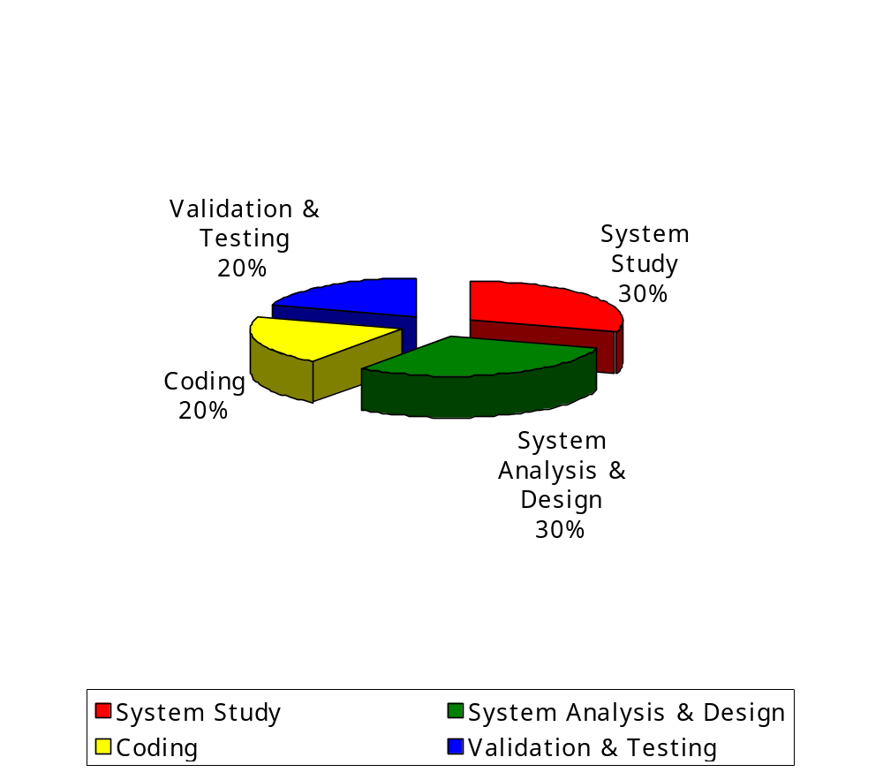

BIBLIOGRAPHY

- MASTERING VISUAL BASIC 6

-EVANGELOS PETROUTSOS

- VISUAL BASIC IN 12 EASY LESSONS

-GREG PERRY

- VISUAL BASIC PROGRAMMING
(BLACK BOOK)

-STEVEN HOLZENER

- DATABASE DEVELOPER’S GUIDE
WITH VISUAL BASIC 5

-ROGER JENNINGS

